Background:
This project will encompass the entirety of the microfiche bill files, including both Finance series and special committee files. The goal is to have everything broken apart into individual files for each combination of committee and bill, organized into folders by legislature and then committee.

STEP 1: Identify the files to combine and split.
- Add your Name and Status (“In Progress”) to the appropriate Table in the Committee Bill File Microfiche Splitter List (X:\Committee Bill Files\ Committee Bill File Microfiche Splitter List)

STEP 2: Determine the fiche range for the appropriate Legislature & Committee
- Use the Finding Aid - Microfiche (Finance + Standing) (X:\ Finding Aid - Microfiche (Finance + Standing)) Excel doc.
- Filter by Year/Session then Committee to determine first and last fiche number needed.
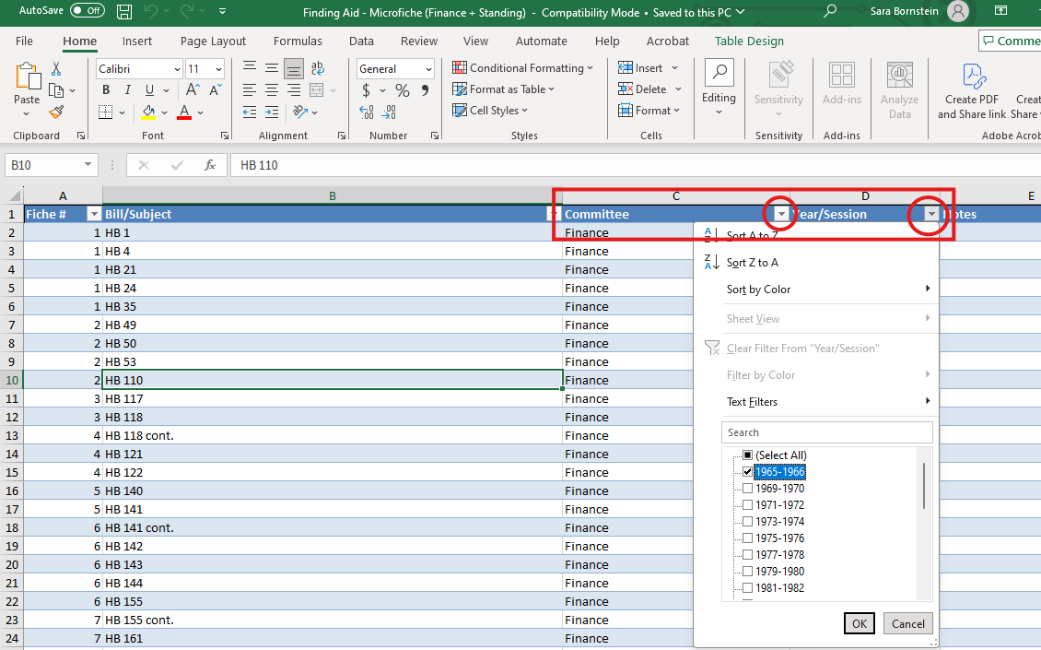

Example: 14th Legislature (1985-1986) & Committee SCRA filtered in Finding Aid results in Fiche #3821-3898

STEP 3: Copy files to be worked on to a designated folder
- Create a folder called “Committee Bill File Splitting” in your shared folder on the (N:\) drive.
- Highlight all master file PDFs (X:\Committee Bill Files\Standing Committees) within the Fiche # range identified in Step 2.
- Combine the PDFs
- Save combined PDFs document inside the “Committee Bill File Splitting” in a new folder named “[Committee Leg#]” (Example: SCRA 14)

STEP 4: Clean up combined PDF document and create bookmarks.
- Open combined document with Adobe Acrobat
- Delete all the bookmarks. Click on Bookmark icon in right-hand sidebar to open bookmark side panel. Select all bookmarks (Ctrl + A) and delete.
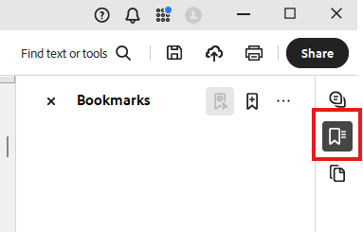
- All Tools > Organize Pages
- Delete the microfiche reel headers.
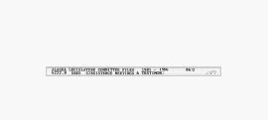
- Delete rescanned pages. Look for CORRECTION page. Delete Correction page and pages before it up to the page that looks the same as the page after the CORRECTION page.
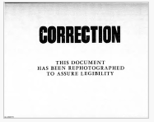
- Delete Records Certification pages.
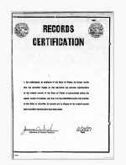
- Rotate upside-down/sideways pages right side up.
- Create new bookmarks: To create a bookmark, select a page, (Ctrl + B) will open Bookmarks Panel, type bookmark name, hit Enter.
  - Each bookmark name will be the file name for each PDF after document is split. Use filename convention [Committee Legislature# Target Name] (Examples: "HEDC28 HB 18" or "SRES26 2-11-09 Instate Use of Cook Inlet Gas")
  - Do not use /\:*?”<>| in bookmark name, but feel free to abbreviate! Especially for departments, and discretionarily do so for other common terms, such as AKLNG. Also, substitute "&" for "and." If filenames are too long, computer stuff breaks, and this should help.
  - Conference committees are CONF##/Bill #, ex. CONF24/HB 94.pdf
  - The first bookmark should be “List of Files” and should bookmark the first page of the List of Files at the beginning of the document.
  - After that, bookmark each Target Page.
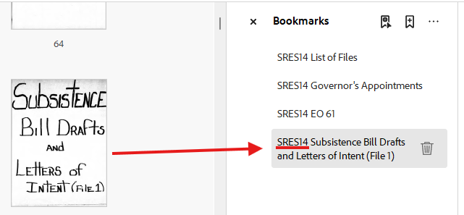
- Remember: SAVE the document often as you prep it for splitting so you don’t lose all your progress!

STEP 5: Split the large document
- SPLIT DOCUMENT: All Tools > Organize Pages > Split > Top Level Bookmarks > click on “Output options,” > Select Target Folder, and “Use bookmark name for file names” – click “OK” twice. Adobe will split the file into individual bill files and put them in the same folder as the original file.
- Save files into a directory structure on your computer as follows: <YYYY-YYYY - ##th Legislature>, based on the years and number of the legislature, ex. "1993-1994 18th Legislature" The next layer should be the 4 character committee code, such as "HRLS"
  - Periodically copy these files into the X:\Committee Bill Files folder, maintaining the full folder structure.

TO CORRECT ERRORS:
If you find an incorrect target or accidentally delete a page from a document, you can create a document in Word, save it as a pdf, and insert it in the document: All Tools > Organize Pages > Insert > From File > Search & select document (e.g. HJUD2). In dialog box select “insert before/after + page number. Remember that the actual page numbers of the document you have created are NOT the same as the page numbers generated by Central Microfilm which are visible on the corners of the document pages.

