Tsunami Debris Docks provide Unique Opportunity for Scientists
By Annie Feidt, APRN - Anchorage | January 23, 2013 - 5:26 pm
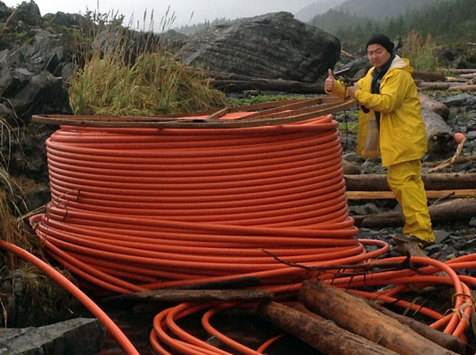
Photo courtesy of GoAK.
Tsunami debris from Japan is fouling shorelines all along the west coast of the United States. It’s also providing a unique research opportunity for scientists studying invasive species. At the Marine Science Symposium in Anchorage this week, Oregon State University associate professor Jessica Miller gave an update on her research work on the two massive docks that washed up in Oregon and Washington last year. APRN’s Annie Feidt reports:
It’s rare for scientists to find perfect field experiments right in their backyard. But that’s what happened last summer to Jessica Miller.
“There was a little bit of buzz in the hallway at work on the 5th of June that hey, something pretty big is on the beach.”
The beach, was just four miles from Miller’s office. And that “something” turned out to be a giant dock, that had been ripped lose in the 2011 Japanese Earthquake and Tsunami. When she first saw it, Miller says she was flabbergasted by just how huge it was- 66 feet long. That night, she called a few colleagues and they agreed to meet there the next morning with buckets and shovels:
“Given the situation, we were fairly systematic, but it’s not like we we had a whole sampling design for a dock, we were just going ‘wow’, I think we need to get these samples. So we tried to sample all the sides of the dock and probably got 30 five gallon bags, and went back to the lab to begin figuring out what was there.”
The scientists quickly realized several of the species were potentially aggressively invasive. So a team from the state of Oregon scraped off all of the living debris, took a blow torch to the dock and then buried two tons of organisms several feet down higher up on the beach. Then the research began. So far, Miller’s team has documented 117 species that likely made the entire trip from Japan to Oregon.

“And it really appears given this diversity of animals, the reason some of them could survive on this dock for so long was that some of them were feeding on other ones on the dock. Sort of an island in the ocean crossing the Pacific.”
Miller says 11 of the species could be invasive, including the European blue mussel, the Japanese sea star and the Asian pink barnacle. Miller says it’s hard to predict how likely they are to become invasive. But if any do take hold, it will be a unique opportunity to study an invasive species from the moment of its arrival. One of the species Miller is most worried about is an Asian seaweed:
“Ondarea is a brown alga that was incredible abundant on the dock and reproductive at the time. And its already established in California. And it’s on one of the 100 worst invasive species list already.”
In late December, another dock washed up on a beach on Washington’s Olympic Peninsula. It was from the same port in Japan and carried a similar mix of creatures with it across the ocean. Miller’s team took samples from that dock as well. But she says invasive species aren’t just arriving on huge objects, like docks.
“A buoy just came up into the Columbia river region. The large black buoys several people are reporting with chiton, a couple species of chitons, mussels and I think an Oyster on it, so you really can have some of the smaller objects bringing in non native species.”
That has implications for Alaska. No large docks have washed on shore in the state. But millions of pounds of debris are piling up on Alaska’s beaches. So far, the state hasn’t documented any invasive species from the debris. Chris Pallister, with Gulf of Alaska Keeper, helped clean about 6 tons of tsunami debris from the southeast Kenai Peninsula this summer. He says he worried about invasive species, but he’s more worried about toxins from the debris:
“I mean you’re talking thousands of miles of coastline that have been impacted by every type of plastic you can imagine and drums and containers of everything from nasty industrial chemicals to household cleaning products that are being scattered all up and down the inter-tidal environment.”
Last summer, the state commissioned a aerial survey to document how much tsunami debris was washing up and where it was concentrating. The survey shows the debris stretches from the Southern tip of Southeast all the way around the Gulf of Alaska and at least part way down the Alaska Peninsula. Montague Island, Kayak Island, south of Cordova and Shuyak Island near Kodiak were identified as hot spots. But so far no state funding and only a tiny amount of federal funding has been appropriated to begin cleaning it up.
Listen to the full story

