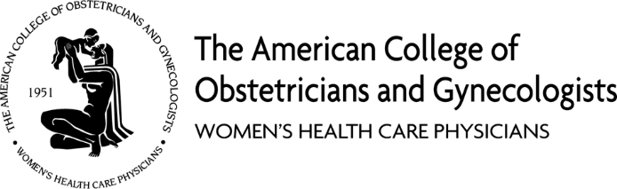
February 9, 2023
RE: ACOG Alaska Section’s Support for AK SB 58 and HB 59
Dear Alaska State Legislators,
The Alaska Section of the American College of Obstetricians and Gynecologists (ACOG), representing more than 93 practicing physicians, writes to express its unwavering support for SB 58 and HB 59 to provide pregnant women who are eligible for Medicaid continuous coverage for twelve months after the end of pregnancy. This legislation could mean the difference between life and death for many Alaska women and would align the coverage for the mother with that of her infant.
For too many new mothers, Medicaid coverage runs out 60 days after the end of pregnancy, although their newborn is guaranteed coverage through the first year of life. Lack of coverage and coverage disruptions contribute to preventable maternal deaths – more than half of which occur after Medicaid coverage ends. National data shows 80 percent of maternal deaths are preventable. Our recent report from the Alaska Maternal Child Death Review identified 85 percent of pregnancy associated deaths as potentially preventable. Giving pregnant individuals continuous Medicaid coverage for at least one year postpartum can help reduce preventable maternal deaths and improve outcomes for moms and babies.
The postpartum period is simultaneously a time of vulnerability and maternal health risk and a transition period with often unmet maternal health needs. Many new moms become uninsured during the vulnerable weeks and months after childbirth due to an arbitrary 60-day Medicaid cut-off post-delivery. Findings from state maternal mortality review committees reveal a growing number of maternal deaths linked to cardiovascular disease, cardiomyopathy, and overdose and suicide, with many of these deaths occurring during the postpartum period.
Our nation’s rate of maternal mortality is rising. Evidence confirms that postpartum insurance disruptions are a major contributing factor to this maternal health crisis. As the largest single payer of maternity care in the country, covering 42 percent of births nationwide and 39 percent of births here in Alaska, Medicaid has a critical role to play. The overall maternal mortality rate in Alaska from 2009-2018 was 8.3 deaths per 10,000 lives births, however racial disparities persist. The maternal mortality rate for Alaska Native women, during the same time frame, was 19.2 deaths per 10,000 live births.
We are working to reduce maternal deaths, address racial disparities, and support the health of parents and infants in Alaska. Extending Medicaid postpartum coverage is critical in reaching these goals.
Thank you for the opportunity to voice our support for SB 58 and HB 59. Please contact Dr. Truitt at sarahttruitt@gmail.com (303-917-1674) or Dr. Stille at kacystille@gmail.com (907-341-9846) with any questions.

Sincerely,

Sarah Truitt, MD, FACOG
ACOG Alaska Section Legislative Chair

Kristen Stille, MD, FACOG
ACOG Alaska Section Vice Chair

