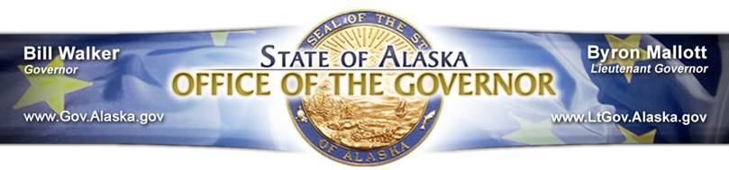
Supporters of Medicaid Reform & Expansion

AARP Alaska
Abused Women’s Aid in Crisis, Inc. (AWAIC)
Ahtna, Incorporated
AK Child & Family
Alaska Association for Homes of Children
Alaska Chamber of Commerce
Alaska Federation of Natives
Alaska Injury Prevention Center
Alaska Literacy Program
Alaska Mental Health Trust Authority
Alaska Municipal League
Alaska Native Health Board
Alaska Native Tribal Health Consortium
Alaska Network on Domestic Violence and Sexual Assault
Alaska Nurses Association
Alaska Pharmacy Association
Alaska Physical Therapy Association
Alaska Primary Care Association
Alaska State Hospital & Nursing Home Association
Alaska Women’s Lobby
American Diabetes Association
Anchorage Chamber of Commerce
Anchorage Community Mental Health Services
Anchorage Faith & Action Congregations Together
Anchorage Human and Social Services Executive Directors
Anchorage Municipal Assembly
Anchorage Neighborhood Health Center
Anchorage Youth Development Coalition (AYDC)
ANCSA Regional Association
Bering Straits Native Corporation
Bristol Bay Native Corporation
Catholic Social Services
Camp Fire USA Alaska Council
CCS Early Learning
Congregation Sukkat Shalom
Covenant House Alaska
Doyon Limited
Fairbanks Community Mental Health Services
Food Bank of Alaska
Juneau Central Council ALF/ CIO
Juneau Tlingit & Haida Community Council
Kenai Peninsula Borough Assembly
Kodiak Area Native Association
Mat-Su Health Foundation
NAACP
NAMI
NEA Alaska
Nine Star Education and Employment Services
Nondalton Tribal Council
RurAL CAP
Sitka Borough Assembly
Municipality of Skagway
thread
United Way of Anchorage
Volunteers of America Alaska
YWCA Alaska

