Alaska State Legislature

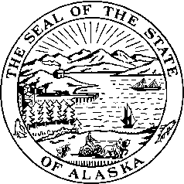

*Interim:*  S*ession:*

716 West 4th Ave. State Capitol Building

Anchorage, Alaska 99501 Juneau, Alaska 99801-1182

(907) 269-0199 (907) 465-4945

## Legislative Budget & Audit Committee

# SB 263 SPONSOR STATEMENT

**TITLE**: “An Act extending the termination date of the Board of Professional Counselors;

and providing for an effective date.”

The Board of Professional Counselors (BPC) was established under the provisions of Title 8, Chapter 29 of Alaska Statutes. BPC consists of five members appointed by the governor. Four members must be professional counselors and one member must be appointed from the general public. Board members serve staggered terms of four years.

The division provides administrative and investigative assistance to occupational boards including BPC. Administrative assistance includes budgetary services and functions such as collection of fees, maintaining files, receiving and issuing application forms, and publishing notice of examinations, meetings, and proposed regulations.

In the opinion of Legislative Audit, the BPC should continue to regulate professional counselors. The board is serving the public interest by promoting the competence and integrity of those who provide services to the public as licensed professional counselors.

SB 263, if enacted, would extend the Board for eight years to June 30, 2018.