Alaska State Legislature

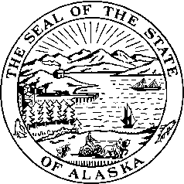

*Interim:*  S*ession:*

716 West 4th Ave. State Capitol Building

Anchorage, Alaska 99501 Juneau, Alaska 99801-1182

(907) 269-0199 (907) 465-4945

**LEGISLATIVE BUDGET & AUDIT COMMITTEE**

**Agenda**

1. Call to Order
2. Minutes
3. RPLs
4. Audit Requests
5. Other Committee Business
6. Audits – Executive Session
7. Adjournment