Alaska State Legislature

SENATOR DONALD C. olson

Chair

Community & Regional Affairs

Member

Senate Finance Committee

Ethics Committee

Legislative Council

Northern Waters Task Force

Education Funding District Cost Factor

Finance Subcommittee Chair

Fish & Game

Health & Social Services

Public Safety

Finance Subcommittee Member

Environmental Conservation

*Session*

Alaska State Capitol, Rm. 508

Juneau, AK 99801

(907) 465-3707

Fax: (907) 465-4821

*Interim*

716 W. 4th Ave. Ste 530

Anchorage, AK 99501

(907) 269-0254

Fax:(907)269-2031

Senator_Donny_Olson@legis.state.ak.us

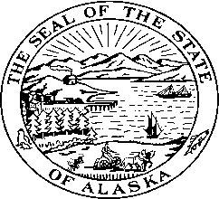

Explanation of Changes to version E

* Page 3, lines 25
  + After the words “aggregate material”: adds “Health risks resulting…”
* Page 6, lines 12-13
  + Adds DNR to coordinate with DOT to establish and maintain a database.