**Alaska Legislature**

**House Special Committee on Energy**

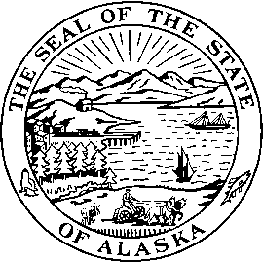

**Rep. Charisse Millett Rep. Doug Isaacson**

Capitol Building, Room 403 Capitol Building, Room 13

Juneau, AK 99801 Juneau, AK 99801

Phone (907) 465-3879 Phone (907) 465-4527

Fax (907) 465-2069 Fax (907) 465-2197 [rep.charisse.millett@akleg.gov](mailto:rep.charisse.millett@akleg.gov) [rep.doug.isaacson@akleg.org](mailto:rep.doug.isaacson@akleg.org)

**Agenda**

**Wednesday, February 20, 2013**

**8:00 – 10:00 a.m.**

**Barnes Committee Room (#124)**

**+PCE Overview**

Sara Fisher-Goad, Alaska Energy Authority

**+Susitna-Watana Hydro Project**

Sara Fisher-Goad, Alaska Energy Authority

Wayne Dyok, Susitna-Watana Hydro Project Manager, Nick Szymoniak, Project Economist.

Bills previously heard/scheduled

* First hearing in first committee of referral

+ Teleconferenced

= Bill previously heard/scheduled

###