Alaska State Legislature

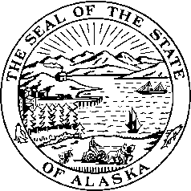

*Interim:*  S*ession:*

716 West 4th Ave. State Capitol Building

Anchorage, Alaska 99501 Juneau, Alaska 99801-1182

(907) 269-0199 (907) 465-4945

**LEGISLATIVE BUDGET & AUDIT COMMITTEE**

Senator Kevin Meyer, Chairman

Date: January 27, 2010

To: Kirsten Waid, Senate Secretary

Suzi Lowell, Chief Clerk

From: Senator Kevin Meyer, Chairman

Legislative Budget & Audit Committee

Re: LB&A Committee Schedule

The Legislative Budget and Audit Committee will schedule the following meeting:

**Date:** Thursday, February 25, 2010 and

**Time:** 4:00 pm

**Location:** Senate Finance Room 532

**Agenda**

1. Call to Order
2. Minutes
3. RPLs
4. Audits – Executive Session
5. AEA Renewable Energy Project Update
6. Other Committee Business
7. Adjournment

**+ - Teleconferenced (By Invitation Only)**