Alaska OWL (Online With Libraries)
Progress Report
March 2013

Alaska OWL (Online With Libraries) provides Alaskans with the benefits and opportunities that come with access to high speed Internet. Through the public libraries of the state, library users have improved access to e-government services, distance education opportunities, public safety training, professional development opportunities and more employment opportunities. OWL focuses on four areas:
1. Providing high speed broadband connections to public libraries with inadequate connectivity.
2. Providing new computing equipment to all participating libraries, including desktop and laptop computers, printers and other peripherals such as headsets, speakers, and wireless routers.
3. Purchasing a videoconferencing unit to be placed in each library and working with a telecommunications vendor and the University of Alaska to create a videoconferencing network for participating libraries.
4. Providing technology assistance and training for staff in all participating libraries.

The OWL project has been working with individual communities in conjunction with vendors GCI, ACS and MTA to install high speed broadband into their library facilities. This process has been frustrating from time to time; however, due to the feedback we have received from libraries with upgraded broadband, the project has been extremely rewarding.

Sonja Marx from the Dillingham library: It has opened up a world we have not had before. Our 'secluded' community has now been 'included' in the opportunity to participate in, learn from, and share with the world our lives. We now have access to what the rest of the United States, as well as the whole world, has been able to enjoy and learn from in communication, education, exploration, entertainment, employment, and so much more.

Libby Caffall Davis from the Hyder Library: The high speed internet was invaluable to the Ketchikan Volunteer Rescue Squad (KVRS) and the Hyder Community in the search and rescue efforts for a local resident in July 2012.
A number of libraries began using the video conferencing immediately and often. Some uses of the video conferencing network --
- high school classes in various communities take courses in chemistry and English literature;
- a mining class is delivered via distance through OWL;
- a library patron used the network for a job interview;
- Senators Begich and Murkowski used the network to read stories to children and talk to teens about their concerns from their offices in Washington DC;
- conferences from the Country Music Hall of Fame, the Great Barrier Reef, and the Royal Tyrrell Museum and many others;
- the National Humanities Forum conducted a statewide board meeting;
- Sitka city officials met with the governor;
- author visits, staff meetings and training events.

Over the past year, over 1500 video conferencing events have taken place using OWL. A few libraries
have yet to get their videoconferencing up and running.

In addition to providing libraries with computer and video equipment it was important to offer training to properly use this equipment. In 2012 four OWL training events focused on basic troubleshooting for IT problems, how to use the new videoconferencing units, how to effectively and safely use the new upgraded bandwidth provided to their libraries, and how to install a wireless hotspot. 113 individuals participated in these events. Currently we are developing training materials for Alaska resources including how to access various Alaska e-government sites.

From the beginning of the OWL project our biggest fear was that we would provide underserved communities with these important resources, and then after the grant was over, they would not be able to afford to sustain them and would be forced to revert to where they were prior to OWL. With this in mind, in September of 2012 we held a Sustainability Summit in Anchorage. We invited all the libraries, along with OWL project partners and telecommunications industry representatives. We also invited speakers including the chair of the Governor’s Broadband Taskforce, and representatives from the American Library Association, the Schools, Health, Libraries and Broadband Coalition, UAA’s Institute of Social and Economic Research (ISER). The objective of this event was to discuss and share the successes of the project, and brainstorm options to secure funding to keep this project alive.

One major way that sustainability can be attained is through the federal E-Rate program. The OWL project funds and the contributions of the local libraries leveraged $2,075,293 in federal E-Rate support during FY 2012 as compared to $68,930 in FY 2009 (pre-OWL).

E-Rate is the federal program which makes internet connection possible for Alaska’s schools and public libraries. The graph below shows the impact of the Alaska OWL Project on E-Rate Funding for public libraries in Alaska.

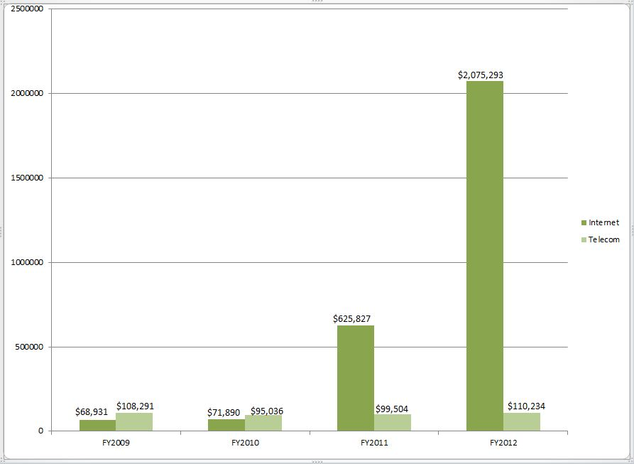
Federal E-Rate Funding for Libraries as a result of OWL investments

