AlaskaCare Employee Health Plan
Plan highlights
- Self-insured plan
- Uses Third-Party Administrator to process claims
- Approximately 16,400 members (6,400 covered employees, 10,000 dependents)
- Three medical plans: economy, standard and premium
- Three types of dental coverage: preventive, standard, premium
- Two types of vision coverage: standard, managed care
Medical Plan Structure
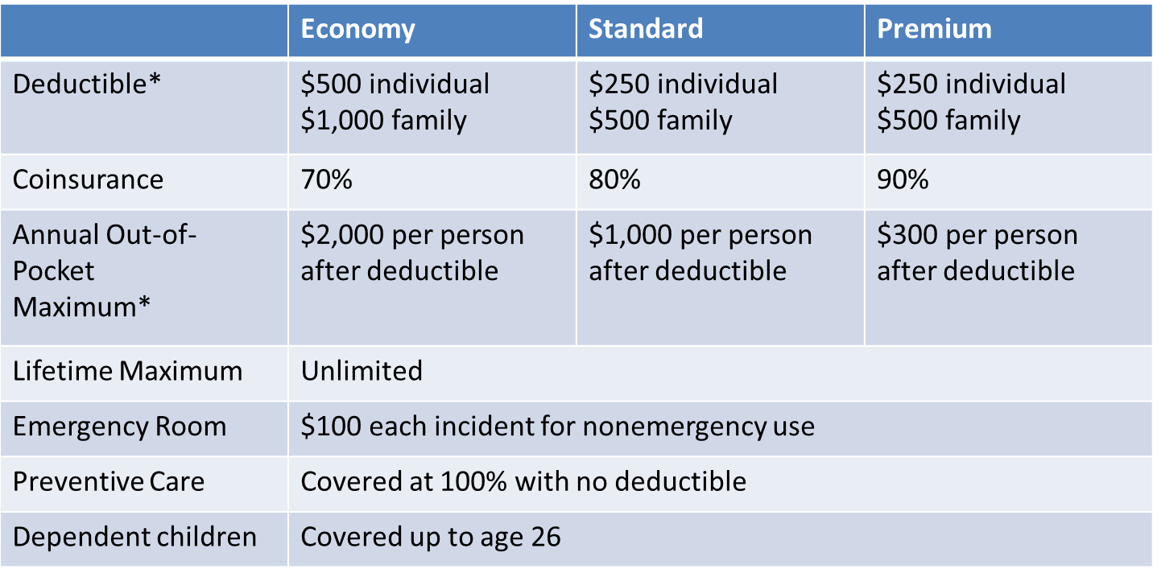
A full comparison chart is available here http://doa.alaska.gov/drb/alaskaCare/employee/plans/medicalPlansCompare.html
Premium Rates FY 13
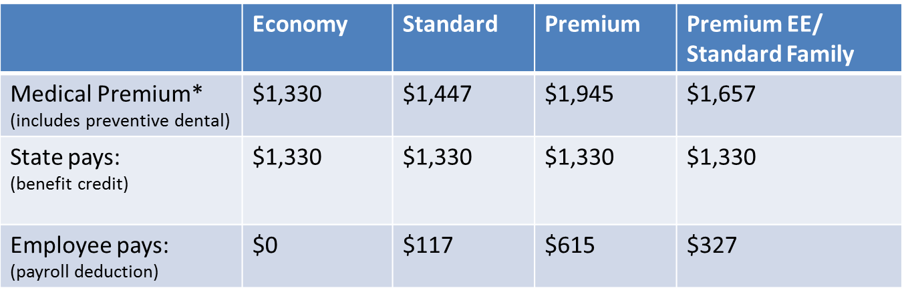
*Actual premiums may be higher depending on the level of vision and dental coverage selected.
See http://doa.alaska.gov/drb/alaskaCare/employee/info/premiums.html for dental and vision rates.

Benefit credit:
- Amount the state contributes per employee per month. It has historically matched the combined cost of the economy plan medical premium and the preventive dental premium
- It is a negotiated item
- In FY 13, the benefit credit is $1,330; for FY 14 this will increase to $1,389
More information available at http://doa.alaska.gov/drb/alaskaCare/employee/info/benefitCredits.html

