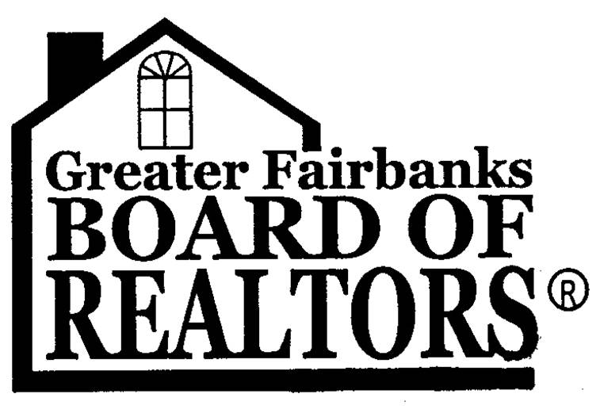 | GREATER FAIRBANKS BOARD OF REALTORS®  1449 Gillam Way  Fairbanks Alaska, 99701  Phone: 907-452-7743  Fax: 907-452-7746

April 17, 2014

RE: HB 282 - "An Act relating to the rights and obligations of residential landlords and tenants; and relating to the taking of a permanent fund dividend for rent and damages owed to a residential landlord."

Dear Senator Kelly,

The Greater Fairbanks Board of REAL TORS• and its membership supports House Bill 282,
which will update the existing Uniform Residential Landlord Act and takes into consideration current circumstances, technologies and laws.

The Greater Fairbanks Board of REALTORS• supports this bill because it will allow landlords to collect a separate pet deposit, change the security deposit refund from 15 days to 30 days, define the meaning of normal wear and tear and allow a landlord to attach a tenant's Permanent Fund Dividend to any judgment for unpaid rent or damages.

The Board believes that by updating this bill it will integrate the best practices for property
managers and protect against potential problems regarding landlords and tenants.

The Board encourages the passage of House Bill 282.

Sincerely,

Brittnie S Welsh
Association Executive
The Greater Fairbanks Board of REALTORS®
The Voice of Real Estate

