March 15, 2016

Summary of Changes to CSHCR17 (TRA)

Page 1, Line 13:
Remove: “aviation”
Insert: “unmanned aircraft systems”

Page 1, Line 15:
Remove: “aviation”
Insert: “unmanned aircraft systems”

Page 2, Line 1:
Insert at the end of the paragraph:
Related earnings into the state’s economy as identified in the May 2013 McDowell Group report prepared for the Alaska Center for Unmanned Aircraft Systems Integration, University of Alaska Fairbanks.

Sincerely.
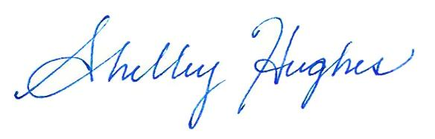

Representative Shelley Hughes
District 11 - Greater Palmer

