ALASKA STATE LEGISLATURE

Rep. Steve Thompson, Chair

1292 Sadler Way, Ste. 323
Fairbanks, Alaska 99701
Phone: (907) 452-1088
Fax: (907) 452-1146
Members:
Rep. Johnson, Vice-Chair
Rep. Austerman
Rep. Herron
Rep. Pruitt
Rep. Kawasaki
Rep. Miller

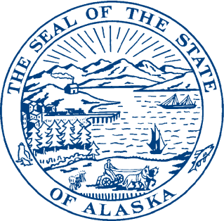

HOUSE SPECIAL COMMITTEE ON FISHERIES

TO: Committee Members and AYK Region Legislators and Staff

FROM: Representative Steve Thompson

RE: House Fisheries Committee Hearing – Salmon Management in the Arctic – Yukon - Kuskokwim Region

LOCATION: Dena’ina Civic and Convention Center
Conference Room 3 (Second Floor)
600 W. Seventh Avenue

DATE & TIME: Wednesday, October 19th at 2:30 p.m.

AGENDA
______________________________________________________________________________

Salmon Management in the Arctic-Yukon-Kuskokwim Region

2:30 – 2:45 p.m. Opening Comments – Chairman Steve Thompson
Representative Bob Herron

2:45 – 3:30 p.m. Alaska Department of Fish & Game – Overview of Management and Funding for the Salmon Fisheries in the AYK Region and Response to Submitted Questions
Cora Campbell, Commissioner, Department of Fish & Game
Jeff Regnart, Director, Division of Commercial Fisheries
John Linderman, AYK Regional Supervisor Commercial Fisheries
Hazel Nelson, Director, Division of Subsistence

3:30 – 3:45 p.m. Resource Management Concerns and Allocation of Management Resources
Kawerak, Inc. – Rose Fosdick

3:45 – 4:00 p.m. Local Input Regarding Policies and Management Issues
Association of Village Council Presidents - Myron Naneng, President

4:00 – 4:15 p.m. Community Involvement in Management Decisions and Monitoring
Yukon River Drainage Fisheries Association - Jill Klein, Executive Director

4:15 – 4:30 Cooperative Research & Monitoring: Fisheries Management Begins at the Local Level
Bering Sea Fishermen’s Association – Karen Gillis, Executive Director
Art Nelson, Policy & Outreach Coordinator

4:30 – 4:45 p.m. Alaska Department of Fish & Game Committee Questions & Department Comments

4:45 – 5:30 p.m. Public Testimony

5:30 p.m. Committee Closing Comments

