ALASKA STATE LEGISLATURE

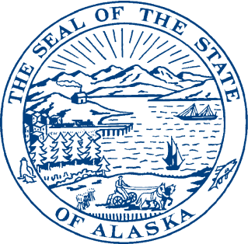
Session:

State Capitol, Room 115
Juneau, Alaska 99801-2186
Phone (907) 465-2327
Fax: (907) 465-5241
Toll Free: (800)336-7383
Interim:

1292 Sadler Way
Fairbanks, Alaska 99701
Phone: (907) 456-8161
Fax: (907) 456-8163
Toll Free: (800)336-7383

Senator Click Bishop

SB 137 Sponsor Statement

Alaska has more earthquakes than any other region in the U.S. and is one of the most seismically active areas in the world. In fact, we are approaching the 50th anniversary of the 1964 Good Friday Earthquake, the most powerful in recorded North American history.
Given the historical record and inevitable potential of future earthquake activity, Alaska needs the Alaska Seismic Hazards Safety Commission. The ASHSC is statutorily designated as an advisory body for seismic hazard safety mitigation. The ASHSC’s overarching purpose is to analyze and disseminate information, review predictions and proposed warnings, and to provide recommendations for seismic safety mitigation.
I would like to see the termination date of the Alaska Seismic Hazards Safety Commission (ASHSC) extended from June 30, 2014 to June 30, 2020. According to the Division of Legislative Audit, the commission has a demonstrated public need and therefore the termination date should be extended.

The public need is proven and the public interest is served in the following ways:

1) The commission assists with seismic hazard safety training efforts. For example, in 2011 and 2012, the ASHSC coordinated with the Department of Military and Veterans Affairs to facilitate training workshops for volunteer first responders who would respond after a severe earthquake.
2) They have significantly improved school safety by collaborating with the Department of Education and Early Development on seismic issues concerning school construction and renovations. Seismic hazard mitigation efforts for schools are an important commission priority, as schools are critical infrastructure.
3) The ASHSC served the public’s interest by making seismic hazards mitigation recommendations to the governor, legislature and private entities through annual reports.
4) The commission helps facilitate collaboration amongst agencies with related missions and private sector entities on seismic hazard mitigation.

