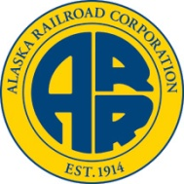

Tanana River Bridge
Quarterly Progress Report
January 15, 2013

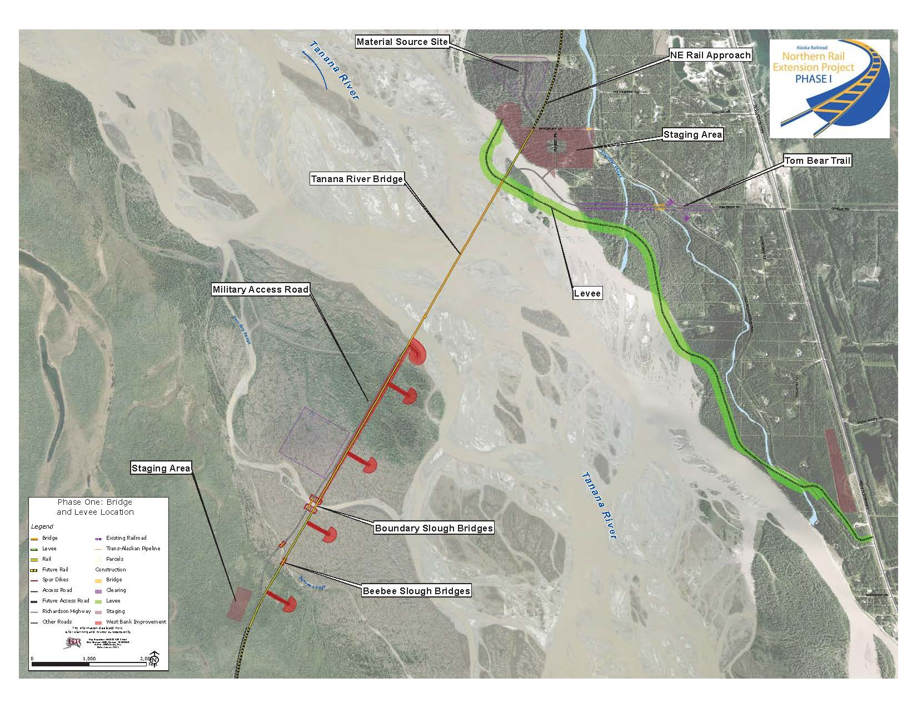
This report covers the period:
October 1, 2012 through December 31, 2012

www.northernrailextension.com

Project Summary

The Northern Rail Extension (NRE) project proposes to construct and operate an approximately 80-mile-long rail extension from Fairbanks to Delta Junction. The NRE project will begin at the existing rail line located on the Eielson Branch line at the Chena Overflow Bridge just south of the community of North Pole and be extended to the community of Delta Junction, with the ability to service Fort Greely.

The project phases are as listed:

- Phase 1: Bridge, approach road, and levee associated with the crossing of the Tanana River near Salcha. (Current Phase)
- Phase 2: Approximately 13 miles of rail from Fairbanks to the Tanana River crossing.
- Phase 3: Approximately 30 miles of rail from the west side of the Tanana River crossing to the Tanana Flats Training Area,
- Phase 4: Approximately 38 miles of rail between the Tanana Flats Training Area and Delta Junction.

Current Status

Rip Rap deliveries ended in early November. Approximately 250,000 tons have been delivered and placed. 180,000 tons remain for delivery in 2013.

Fourth quarter of 2012 saw completion of Piers 2, 3, 4, 8, 9, 11 and 17. These piers are all wrapped in blankets and plastic for the winter. Piers 16, 15, 7, and 6 are staged for concrete placement and completion in February, March and April prior to break up. Additional piers may be started based on weather conditions at the time. The contractor will fall short of their goal of completing 14 piers prior to break up. However, with the early delivery of the bridge girders the project is still tracking on schedule.

The 165’ girder deliveries from Valdez to the site began in November. 14 of 80 girders have been delivered to the site. 32 are scheduled to be on site by February 1st with the balance expected prior to weight restrictions, around June 1st. The bridge has 20 spans, consisting of 4 girders for each span. Earlier than scheduled delivery of girders will allow the contractor to loft several girder spans prior to break up. This will allow the contractor to build less river access than originally planned for the 2013/2014 construction season

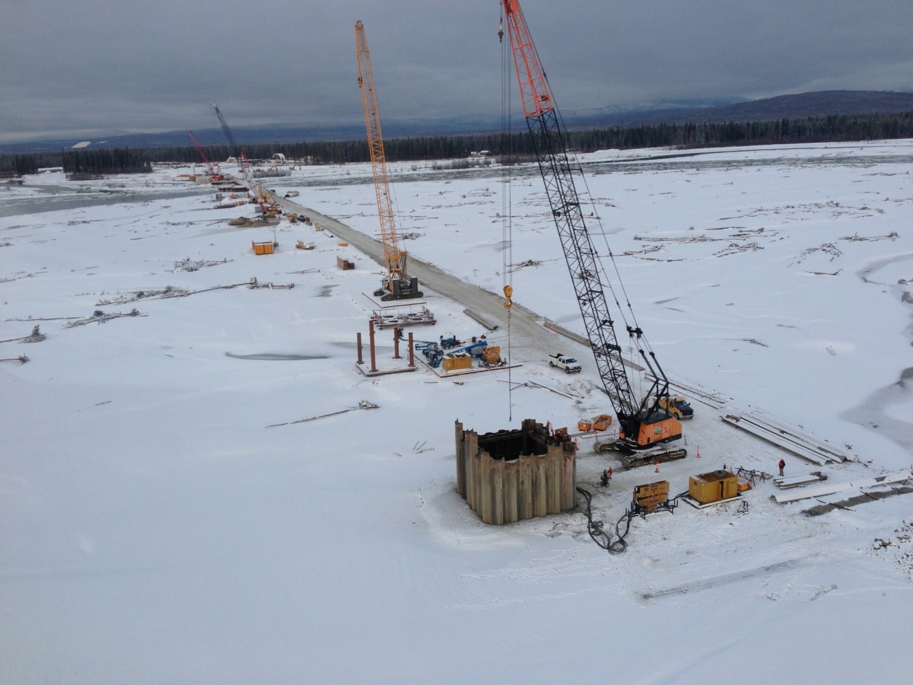

Next Quarter Outlook

First quarter of 2013 activities will include:

- Continued girder deliveries to the site from Valdez.
- Balance of girders delivered to Valdez from the fabrication shop.
- Completion of piers 6, 7, 15, and 16 by the end of March.
- Lofting of some girder spans onto completed piers.

Safety

7
Incidents this Quarter
90
Injury Free Days
10
Total incidents to date

Alaska Work Force (this quarter)
123
Total Manpower on Site
86
Alaskan Manpower on Site
70% Alaskans employed on-site this Quarter

Alaskan Companies providing services:
Construction
- Rolling Stone Construction: Gravel Salcha
- Alaska Quality Insulators: Office Set up North Pole
- Brice Inc: Rip Rap Fairbanks
- Alaska Industrial: Trucking Fairbanks
- Northstar Terminal and Stevedore: Crane Valdez
- Brown’s Hill Quarry, Rip Rap North Pole
- JD Steel: Ironwork-Rebar Salcha
- HC Redimix: Concrete North Pole
- Code 3 Logistics: On-Site Trucking North Pole
- Bighorn Enterprises: Trucking Fairbanks
- Arctic Surveys Company: Survey Fairbanks
- Warwick Surveying: Survey Anchorage
- Carlile: Trucking Anchorage

Engineering
- HDR Alaska: Contract Management/Engineering Anchorage
- Hanson Alaska: Bridge Engineering Anchorage
- Shannon and Wilson: Geotechnical Engineering Fairbanks
- PDC Inc: Survey Fairbanks
- MAPPA Testing Services Fairbanks

Public Outreach

- On site open House held December 8th for the local community. Holiday turkeys were distributed. Principal of Salcha elementary provided a presentation of the school’s participation in the project required Pile Driver Slough monitoring experience.

Funding

 | Spent FRA | Remaining FRA | Spent State Funds | Remaining State Funds | Total
Engineering, Design, Permitting | $ 13,547,597 | $ - | $ 821,562 | $ 3,130,841 | $ 17,500,000
Right-of-Way | $ 635,384 | $ - | $ 213,361 | $ - | $ 848,745
Construction Administration | $ 3,671,425 | $ - | $ 2,605,670 | $ 4,987,521 | $ 11,264,616
ARRC Contingency | $ - | $ - | $ - | $ 5,061,813 | $ 5,061,813
Construction Contract | $ 52,373,840 | $ 33,971,754 | $ 1,424,435 | $ 65,754,797 | $ 153,524,826
Total | $ 70,228,246 | $ 33,971,754 | $ 3,911,477 | $ 78,934,972 | $ 188,200,000

Schedule
August 2014
Original Estimated Schedule completion Date:
August 2014
Current Estimated Schedule completion Date

Project Milestones
Major Project Milestones
 | Date | Status
Final Design and Permits | July-11 | Complete
Construction Contract | July-11 | Complete
Office Complex & Staging Area | November-11 | Complete
Utility Relocation | November-11 | Complete
North Bank Levee | July-12 | Complete
South Bank Spur Dikes | September-13
Bridge Sub-Structure | March-14
Bridge Super-Structure | March-14

ARRC Project Staff
On-Site Project Manager
Mark Peterburs– Project Director
Salcha Project Office – 677-4731
748-1767 or 378-1762 (cell numbers)
peterbursm@akrr.com

Anchorage Staff
Tom Brooks – ARRC Chief Engineer
327 West Ship Creek Avenue
Anchorage, AK 99501
907-265-2595
brookst@akrr.com

Clark Hopp – Director Special Projects
327 West Ship Creek Avenue
Anchorage, AK 99501
907-265-2372
hoppc@akrr.com

www.northernrailextension.com

