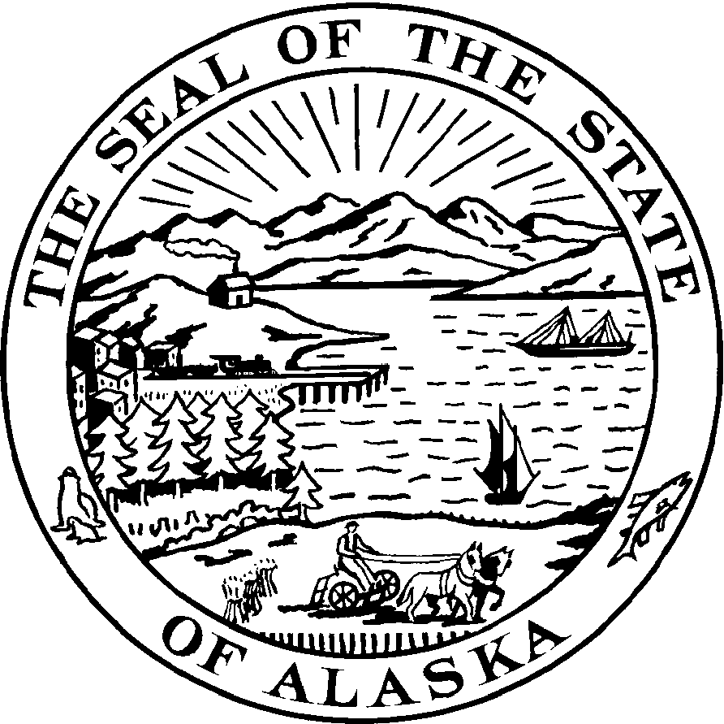

REPRESENTATIVE BILL THOMAS
ALASKA STATE LEGISLATURE DISTRICT 5
e-mail: Representative.Bill.Thomas@legis.state.ak.us
webpage: www.akrepublicans.org/thomas/
State Capitol
Juneau AK, 99801-1182
907-465-3732
888-461-3732
FAX 907-465-2652

Explanation of Differences Between
SB 210(JUD) and HB 334 (RLS)

Page 1, Lines 6-9

Language added to HB 334 which clarifies that one of the purposes of the bill is to ensure that the deployed parent is afforded the maximum opportunity to have contact with his/her child during the period of deployment.

Page 2, Line 10

HB 334 deletes the reference to "an additional 10 days' notice" as it is inconsistent with the intent of the bill to expedite hearings for deploying parents.

Page 2, Lines 13-14

HB 334 adds language that a parent may waive their rights in writing or on the record during a court proceeding.

Page 2, Line 19

HB 334 requires "each parent," not just the nondeployed parent, to facilitate contact between the other parent.

Page 3, Line 18

HB 334 inserts a definition of "parent" that includes the legal guardian of a child.

Page 4, Line 31

HB 334 references the definition of "parent" that is mentioned above.

Page 5, Lines 20-25

HB 334 has an indirect court rule amendment due to the requirement for an expedited hearing if a deploying parent requests one. The court rule being amended is Rule 77.

Page 5, Lines 26-31 and Page 6, Lines 1-2

HB 334 has a conditional effect. The sections of the bill pertaining to the change to Rule 77 will not take effect unless they receive to 2/3 vote of each body of the legislature.

