DATE: January 27, 2020

TO: Representative Harriet Drummond
Representative Sara Hannan
Co-Chair, House Community and Regional Affairs Committee

FROM: Representative Andi Story

RE: HB 193 – SECOND VERSE OF ALASKA'S STATE SONG

I respectfully request that the House Community and Regional Affairs Committee schedule House Bill 193 – SECOND VERSE OF ALASKA'S STATE SONG to be heard in House Community and Regional Affairs Committee.

Please find attached:

- House Bill 193 version A
- Sponsor Statement
- Supporting Document – Letter from University of Alaska Foundation

Thank you for your consideration. If you have any questions, please do not hesitate to contact me or my staff, Caitlyn Ellis, at 465-3744.

Sincerely,
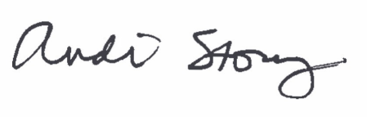
Rep. Andi Story

