28th Alaska State Legislature

Senator John Coghill, Chairman
State Capitol Building
Room 119
Juneau, AK 99801-1182
(907) 465-3717

Senator Lesil McGuire
Vice-Chair
State Capitol Building
Room 103
Juneau, AK 99801-1182
(907) 465-2995

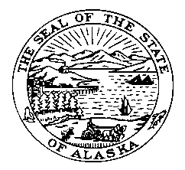

Senate Judiciary Committee

SPONSOR STATEMENT
Omnibus Crime/Corrections Bill
CSSB64 (STA) – Version O

Senate Bill 64 will modify, and in some cases, adopt new statutes in order to cut state spending on corrections while maintaining and improving public safety. Court-ordered treatment programs are an effective means of assisting and providing incentives for DUI offenders to seek treatment and become more productive members of society.

Main sections of this bill:

Sentencing Commission: This bill will establish the Alaska Sentencing Commission. The Commission is intended to review, analyze and evaluate the effect of sentencing laws and practices of the criminal justice system. The Commission will be made up of members from the legislature, state agencies, retired and active judges, native community leaders, and victims’ rights advocates.

Limited License: SB 64 permits Therapeutic Court participants the opportunity to receive a limited license upon successful adherence to program requirements. These amendments make changes to misdemeanor and felony DUI offenders.

Probation and Parole Accountability with Enforcement: There are new duties for the Commissioner of the Department of Corrections, and the Parole Board. The Commissioner and Parole Board shall establish a drug testing program for eligible offenders. The program requires a probation or parole officer to file a petition to revoke a limited license if the person fails to appear, tests positive for controlled substances or alcohol, or fails to follow any condition ordered by the court.

