Representative Jim Colver

SESSION
Alaska State Capitol
Juneau, AK 99801
Phone: (907) 465-4859
Fax: (907) 465-3799
Toll Free: 888-465-4859

INTERIM
600 E. Railroad Avenue
Wasilla, AK 99654
Phone: (907) 373-6287
Fax: (907) 373-6288

Alaska State Legislature House District 9

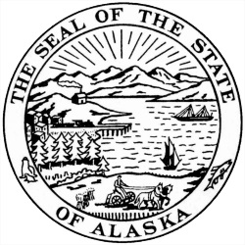

HB 98 – AN ACT RELATING TO AN EXEMPTION FROM JURY DUTY FOR TEACHERS

HB 98: This bill exempts Alaska's teachers from jury duty service requirements during the school year. With more required tests and teacher evaluation requirements crowding out valuable classroom time, this is a simple, straight forward proposal to try and keep our teachers in the classroom and our students learning.

