Interior Distance Education of Alaska
IDEA

IDEA is the homeschool support program of the Galena City School District, serving the needs of students throughout Alaska since 1997. We are privileged to partner with homeschooling parents, providing resources and support to committed parents who individualize education for each child.

Galena City School District
Superintendent: James Smith
P.O. Box 299
Galena, Alaska 99741

Historical Background
IDEA (Interior Distance Education of Alaska) was created by the Galena City School District in 1997 to support homeschooling families. The enrollment that first year surprised us all when it went to 1157 and then tripled the following year. Of the students enrolled in the first year of IDEA, 88% of them had never attended public or private school, which confirmed to us that IDEA was meeting a need among Alaskan students. Our mission is to provide resources and support to parents who have elected to educate their children at home; to achieve a partnership with families that honors the efforts and dedication of homeschooling parents. Presently our enrollment stays steady at around 3500 students in kindergarten through 12th grade. We operate offices in Juneau, Soldotna, Anchorage, Wasilla and Fairbanks.
Current Student Enrollment
Our enrollment at the end of the count period this fall was 3449.65 FTE. This represented a drop of 95.45 students from the previous school year. We are presently involved with our reenrollment process for current students and we have opened our online forms for enrollment for new families for next year. The 08-09 school year represented the first year that we were required to remain open for enrollment year around. Presently we have enrolled 107 new students since the end of the count period. In the past we had closed enrollment after the count period. The following chart shows our current demographic profile of our students.
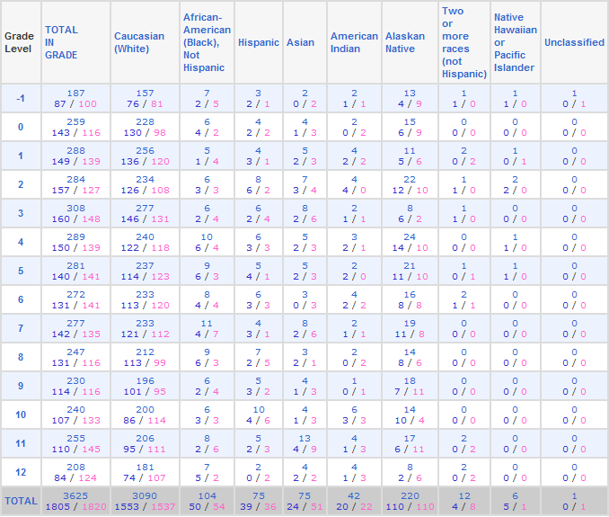
Because IDEA is a statewide program, our students are spread across the state. We have structured IDEA by regions; our enrollment in each region is presented below.
Student Enrollment by Region

Region A (Anchorage area) | 872
Region F (Fairbanks area) | 903
Region MS (Mat-Su Valley) | 894
Region K (Kenai Peninsula) | 441
Region SE (Southeast) | 297
Region G (off the road system) | 216

Based upon employment and economic trends and military deployments our enrollment by regions varies. To more clearly understand the movement of students within the various districts and programs throughout the state I have attached the enrollment comparison that we do each year based upon the numbers reported by DEED after the fall count period is complete. Funding for correspondence programs is governed by AS 14.17.430 which states that we receive 80% of the base student allocation and we do not receive funds for special education or federal programs.

Public School Funding for All Correspondence Schools FY Comparison |  |  |  | Base of $5,480;  using $4,384
School District | FY08 | FY09 | Difference
Alaska Gateway | 37.96 | 57.64 | 19.68 | 86,277.12
Aleutian Region | 0.00 | 0.00 | 0.00 | 0.00
Aleutian East | 0.00 | 0.00 | 0.00 | 0.00
Anchorage | 874.62 | 894.20 | 19.58 | 85,838.72
Annette Island | 0.00 | 0.00 | 0.00 | 0.00
Bering Strait | 0.00 | 0.00 | 0.00 | 0.00
Bristol Bay | 0.00 | 2.00 | 2.00 | 8,768.00
Chatham | 3.00 | 2.00 | (1.00) | (4,384.00)
Chugach | 168.50 | 158.85 | (9.65) | (42,305.60)
Copper River | 40.05 | 49.00 | 8.95 | 39,236.80
Cordova | 0.00 | 0.00 | 0.00 | 0.00
Craig | 411.00 | 394.66 | (16.34) | (71,634.56)
Delta/Greely | 329.65 | 279.80 | (49.85) | (218,542.40)
Denali | 342.95 | 181.14 | (161.81) | (709,375.04)
Dillingham | 7.00 | 0.00 | (7.00) | (30,688.00)
Fairbanks | 283.57 | 252.18 | (31.39) | (137,613.76)
Galena | 3545.10 | 3449.65 | (95.45) | (418,452.80)
Haines | 19.00 | 15.00 | (4.00) | (17,536.00)
Hoonah | 0.00 | 0.00 | 0.00 | 0.00
Hydaburg | 0.00 | 0.00 | 0.00 | 0.00
Iditarod Area | 100.60 | 85.73 | (14.87) | (65,190.08)
Juneau | 87.22 | 76.40 | (10.82) | (47,434.88)
Kake | 0.00 | 0.00 | 0.00 | 0.00
Kashunamiut | 0.00 | 0.00 | 0.00 | 0.00
Kenai Peninsula | 847.00 | 893.53 | 46.53 | 203,987.52
Ketchikan Gateway | 0.00 | 59.20 | 59.20 | 259,532.80
Klawock | 0.00 | 0.00 | 0.00 | 0.00
Kodiak Island | 70.25 | 85.65 | 15.40 | 67,513.60
Kuspuk | 0.00 | 0.00 | 0.00 | 0.00
Lake & Peninsula | 0.00 | 0.00 | 0.00 | 0.00
Lower Kuskokwim | 0.00 | 0.00 | 0.00 | 0.00
Lower Yukon | 0.00 | 0.00 | 0.00 | 0.00
Mat-Su | 1462.40 | 1484.05 | 21.65 | 94,913.60
Nenana | 698.00 | 818.08 | 120.08 | 526,430.72
Nome | 4.00 | 8.50 | 4.50 | 19,728.00
North Slope | 0.00 | 0.00 | 0.00 | 0.00
Northwest Arctic | 0.00 | 0.00 | 0.00 | 0.00
Pelican | 0.00 | 0.00 | 0.00 | 0.00
Petersburg | 0.00 | 0.00 | 0.00 | 0.00
Pribilof | 0.00 | 0.00 | 0.00 | 0.00
Saint Mary's | 0.00 | 0.00 | 0.00 | 0.00
Sitka | 34.78 | 37.90 | 3.12 | 13,678.08
Skagway | 0.00 | 0.00 | 0.00 | 0.00
Southeast Island | 3.00 | 0.00 | (3.00) | (13,152.00)
Southwest Region | 0.00 | 0.00 | 0.00 | 0.00
Tanana | 0.00 | 0.00 | 0.00 | 0.00
Unalaska | 0.00 | 0.00 | 0.00 | 0.00
Valdez | 0.00 | 0.00 | 0.00 | 0.00
Wrangell | 0.00 | 0.00 | 0.00 | 0.00
Yakutat | 0.00 | 0.00 | 0.00 | 0.00
Yukon Flats | 0.00 | 0.00 | 0.00 | 0.00
Yukon/Koyukuk | 1015.14 | 1085.28 | 70.14 | 307,493.76
Yupiit | 0.00 | 0.00 | 0.00 | 0.00
Mt. Edgecumbe | 0.00 | 0.00 | 0.00 | 0.00
TOTALS | 10384.79 | 10370.44 | (14.35)

Special Education Services
The IDEA program works very hard to meet the needs of all enrolled students. We follow all federal and state guidelines to provide appropriate special education services. Each student has an IEP team that meets to determine the Least Restrictive Environment. We strive to meet the individual needs of the student through co-operative agreements with the local school district or by specialized training by our special education staff. We presently serve 140 special education students with 7 certified and 1 classified staff member and also employ speech services through SERRC to meet our needs outside of our staffing ability. Presently we provide service to 11 of the 13 disability categories within special education; we respect the boundaries of the local school districts and do not provide direct services to our students.

Staffing
To meet the needs of our student body, we employ 30 certified teachers and 28 classified support staff. All of our certified teachers are highly qualified in one or more areas and a few are highly qualified in as many as 8 areas. Having a strong and varied staff allows us to meet the HQ requirement.

Student Performance
Families enter into homeschooling for a variety of reasons and with a student turnover rate of close to 1/3 some years our performance has its up and downs. The most important factor that contributes to our success is parental involvement. This one factor has the most impact on our continued high student performance.
To compare our students against other schools’ performance is problematic. It is very difficult to find a program with similar demographics. As the largest program in the state, we have a Herculean task to see that all IDEA students participate in the state testing in the spring. Last year we tested 2076 students at 72 different testing sites around the state. The following graphs display our student performance in the SBA’s for grades 3 – 10 over the last four years, showing the comparison between IDEA test scores and the state average in each subject area.

% Advanced/Proficient
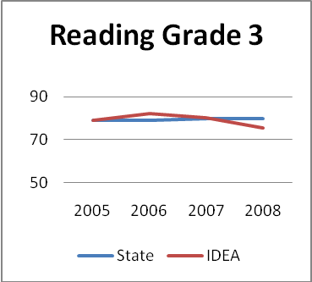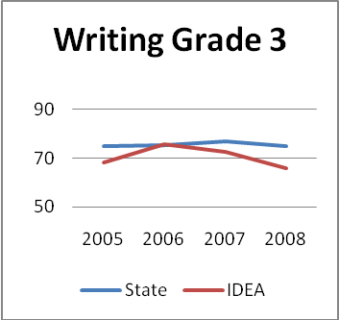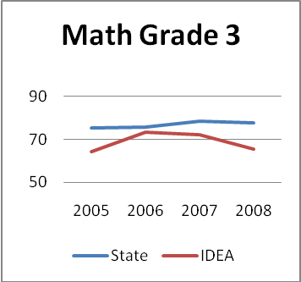
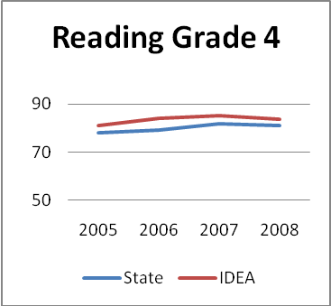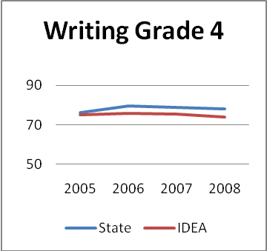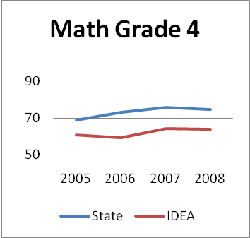
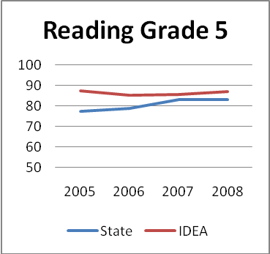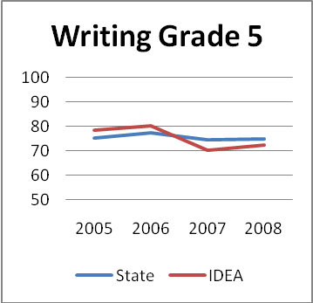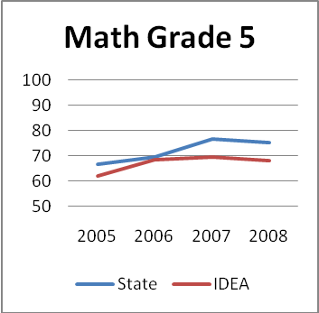
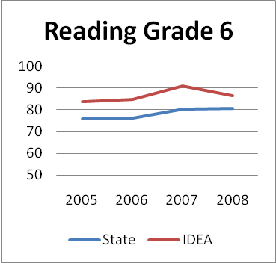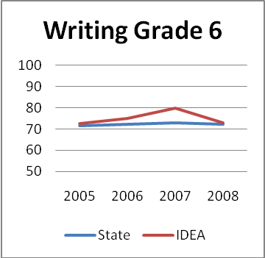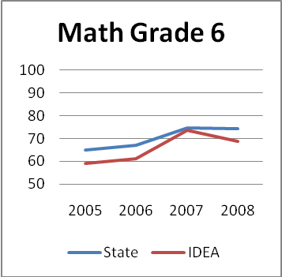
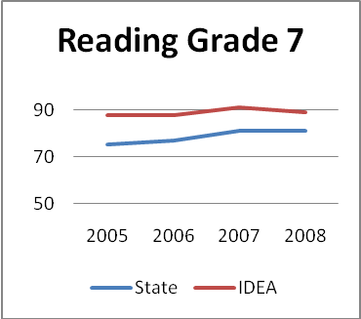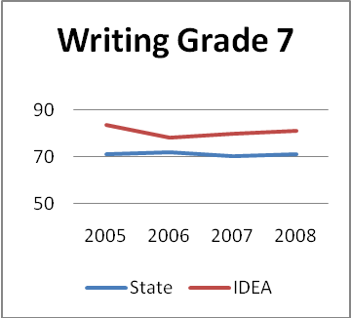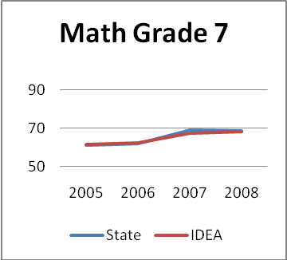
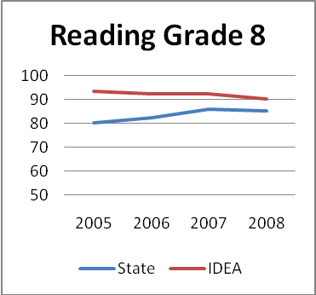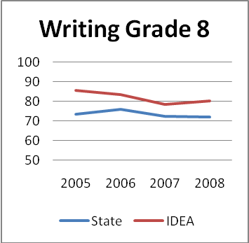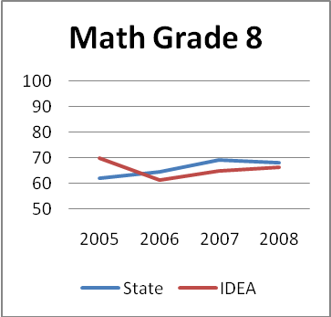
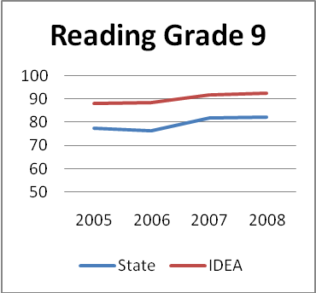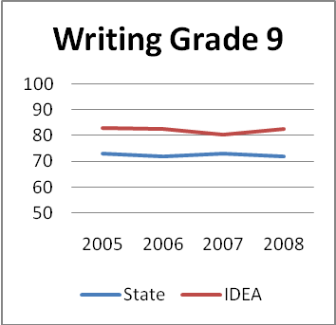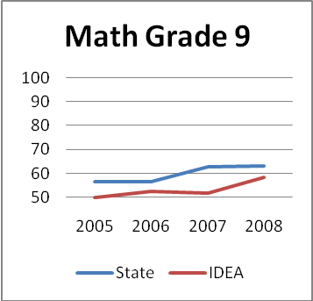
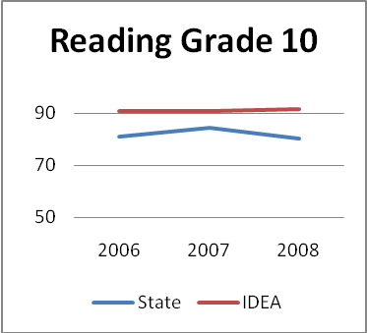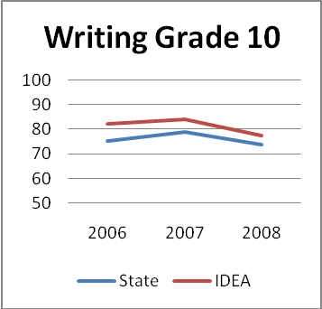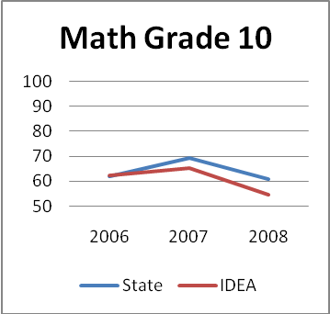

As a program we strongly encourage the families to use the GLE’s and state standards as we work with them to develop their students’ Individual Learning Plan (ILP) each school year. We have discovered that materials favored by the one-on-one teaching environment of the homeschooling family often presents information in a different order than is laid out in the state guidelines, particularly in the primary years. However, as the students progress through the years, student achievement levels increase.
Graduation rates and dropout rates are a topic of much conversation lately. Last year we started a program within IDEA which we call I-Grad. I-Grad is a dropout recovery program designed for students who have been unsuccessful in other school settings and for whom the regular IDEA program would not be a good fit. I-Grad helps students finish their high school education by taking online classes and through credit recovery. Presently we have 105 students enrolled in I-Grad. This past year we found that our graduation rate had fallen. After analysis of the reasons for this, we put some changes into effect within IDEA to address the problem. The following graph tracks our performance since 1999.

School Year | Graduation Rate | Dropout Rate | Enrollment
07-08 | 42.5% | 6.1% | 3566
06-07 | 63.1% | 3.3% | 3525
05-06 | 79.1% | 1.3% | 3457
04-05 | 72.9% | 1.8% | 3554
03-04 | 90.2% | 1.6% | 3769
02-03 | 49.6% | 0.8% | 3612
01-02 | 100.0% | 1.0% | 3453
00-01 | 100.0% | 0.1% | 3104
99-00 | 98.8% | 1.0% | 3487

IDEA is currently at level 5 2nd year for AYP. Because of our size we have found this a difficult target to reach in all areas. We are currently providing tutoring opportunities and workshops to the families around the state where we have identified lower performing students.

Conclusion
The Galena City School Board has supported and been actively engaged in the development and operation of the IDEA program from its inception. They believe in diversity and educational opportunities for all students. In addition to providing oversight and direct involvement in program decisions, the school board brings a group of IDEA parents to Galena itself for a few days each year, with the goal of increased communication and understanding between the parents in IDEA and the school board members.
The IDEA program will continue to recognize and validate the families in their belief in choice and their desire/ability to homeschool their children. We have found that most parents who commit to homeschooling also commit themselves to their own education and apply themselves to learning about the materials and teaching techniques that will best meet the needs of their students. We offer a huge range of materials that parents can use, and provide regular workshops on teaching tips and techniques. Our students participate in statewide educational events such as Spelling Bee, Geography Bee, Academic Decathlon, Close Up in both our state and nation’s capitals, and others. As a matter of fact, we just finished the state Battle of the Books yesterday. IDEA students took first in high school and grades 5-6, were part of the three-way tie for second in grades 7-8, and were third in grades 3-4.
Homeschooling is not the answer for everyone, but it is a viable alternative with proven success. Tailoring education to each student’s needs provides for a great deal of flexibility, which allows each student to excel in his or her own way while still meeting the expectations of the state. We are proud of our support of homeschoolers these past twelve years and look forward to our continuing partnership with them.

