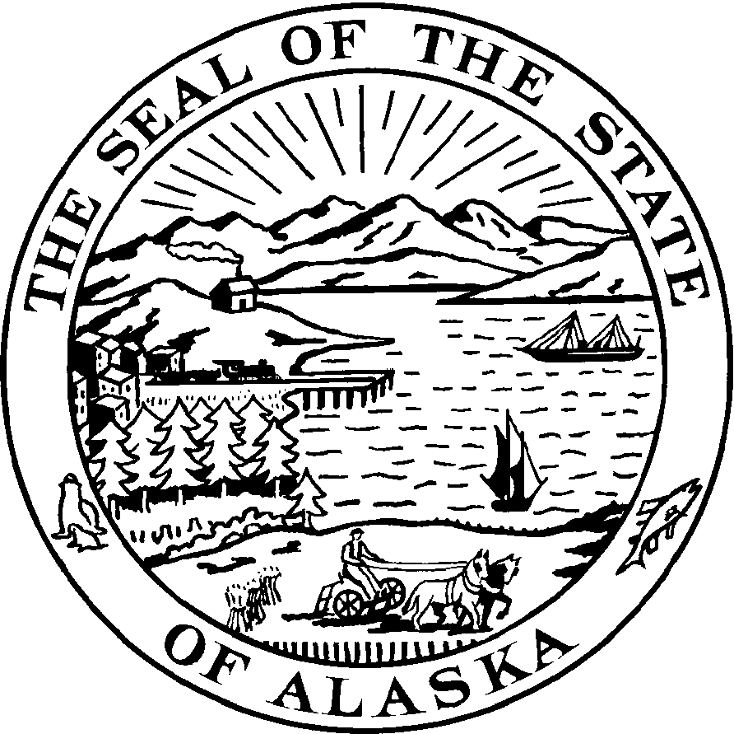
Representative Alan Austerman

Alaska State Legislature

Sectional Analysis
House Bill 150

“An Act repealing certain provisions relating to modifying the factors that apply to calculate the amount of power cost equalization; providing for .”

Bill Section 1. Repeals the substantive law provision, sec. 3, ch. 2, 4SSSLA 2008, that, if left unamended, would restore the former factors that apply to calculate the amount of power cost equalization payable under the Power Cost Equalization Program.

Bill Section 2. Is a contingency provision so that, if House Bill 150 is passed late in the session and is substantially delayed in transmittal to the governor, or the governor otherwise fails to act to approve the bill until at or beyond the June 30, 2009, transitional date, the new provisions are made retroactive so that the legislature’s intent (to eliminate the scheduled formula calculation change) is fully and seamlessly carried out.

Bill Section 3. Repeals the related delayed effective date provision, sec. 11, ch. 2, 4SSLA 2008, that, on June 30, 2009, would provide for restoration of the former factors under that Power Cost Equalization formula. This bill section is, in effect, the repeal of an effective date provision that, under the Manual of Legislative Drafting, requires that it be separately set out and noticed in the bill title (“providing for an effective date by repealing the effective date of sec. 3, ch. 2, 4SSLA 2008”). of Legislative Drafting at pp. 12-13. This change affects an effective date in the earlier bill and requires a two-thirds vote in each house for adoption.

Bill Section 4. Gives the measure an immediate effective date and requires a two-thirds vote in each house for adoption.

This sectional analysis is drawn from a memorandum prepared by Legal Services, Legislative Affairs Agency, at the request of staff of Senator Lyman Hoffman. The full detail of that memorandum, dated January 28, 2009, is available as part of the bill packet for House Bill 150.

_______
February 25, 2009 26-LS0661\A

