ALASKA STATE LEGISLATURE

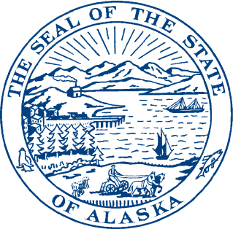
Interim:

1292 Sadler Way, Ste. 308
Fairbanks, Alaska 99701
Phone: (907) 452-1088
Fax: (907) 452-1146
Toll Free: (877) 465-3004
Session:

State Capitol Building

Room 428
Juneau, Alaska 99801-2186
Phone (907) 465-3004
Fax: (907) 465-2070
Toll Free: (877) 465-3004

REPRESENTATIVE STEVE THOMPSON
DISTRICT 10

Explanation of Changes version A to Version I (2.22.12)

- Moves above-ground natural gas storage facilities into their own section of law in AS 43.20.

- The size of a storage tank facility applying for a credit must be verified by a professional engineer.

- For the purposes of determining the amount of the credit, the costs incurred to establish an above ground facility shall be submitted to the department with verification by an independent certified public accountant, licensed in the state.

- Clarifies how a person not subject to taxes under this chapter can claim a payment.

