Alaska State Legislature
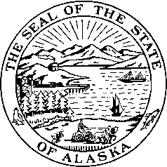
Interim: Session:
716 West 4th Ave. State Capitol Building
Anchorage, Alaska 99501 Juneau, Alaska 99801-1182
(907) 269-0199 (907) 465-4945

LEGISLATIVE BUDGET & AUDIT COMMITTEE

Agenda

- Call to Order
- Other Committee Business
Testimony from Plaintiffs in Moore v. State of Alaska case
- Adjournment

