Alaska State Legislature
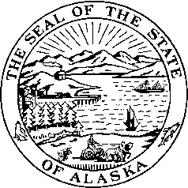
Interim: Session:
716 West 4th Ave. State Capitol Building
Anchorage, Alaska 99501 Juneau, Alaska 99801-1182
(907) 269-0199 (907) 465-4945

LEGISLATIVE BUDGET & AUDIT COMMITTEE

Senator Kevin Meyer, Chairman

Date: January 27, 2010

To: Kirsten Waid, Senate Secretary
Suzi Lowell, Chief Clerk

From: Senator Kevin Meyer, Chairman
Legislative Budget & Audit Committee

Re: LB&A Committee Schedule

The Legislative Budget and Audit Committee will schedule the following meeting:

Date: Thursday, February 25, 2010 and
Time: 4:00 pm
Location: Senate Finance Room 532

Agenda
- Call to Order
- Minutes
- RPLs
- Audits – Executive Session
- AEA Renewable Energy Project Update
- Other Committee Business
- Adjournment

+ - Teleconferenced (By Invitation Only)

