ALASKA STATE SENATE
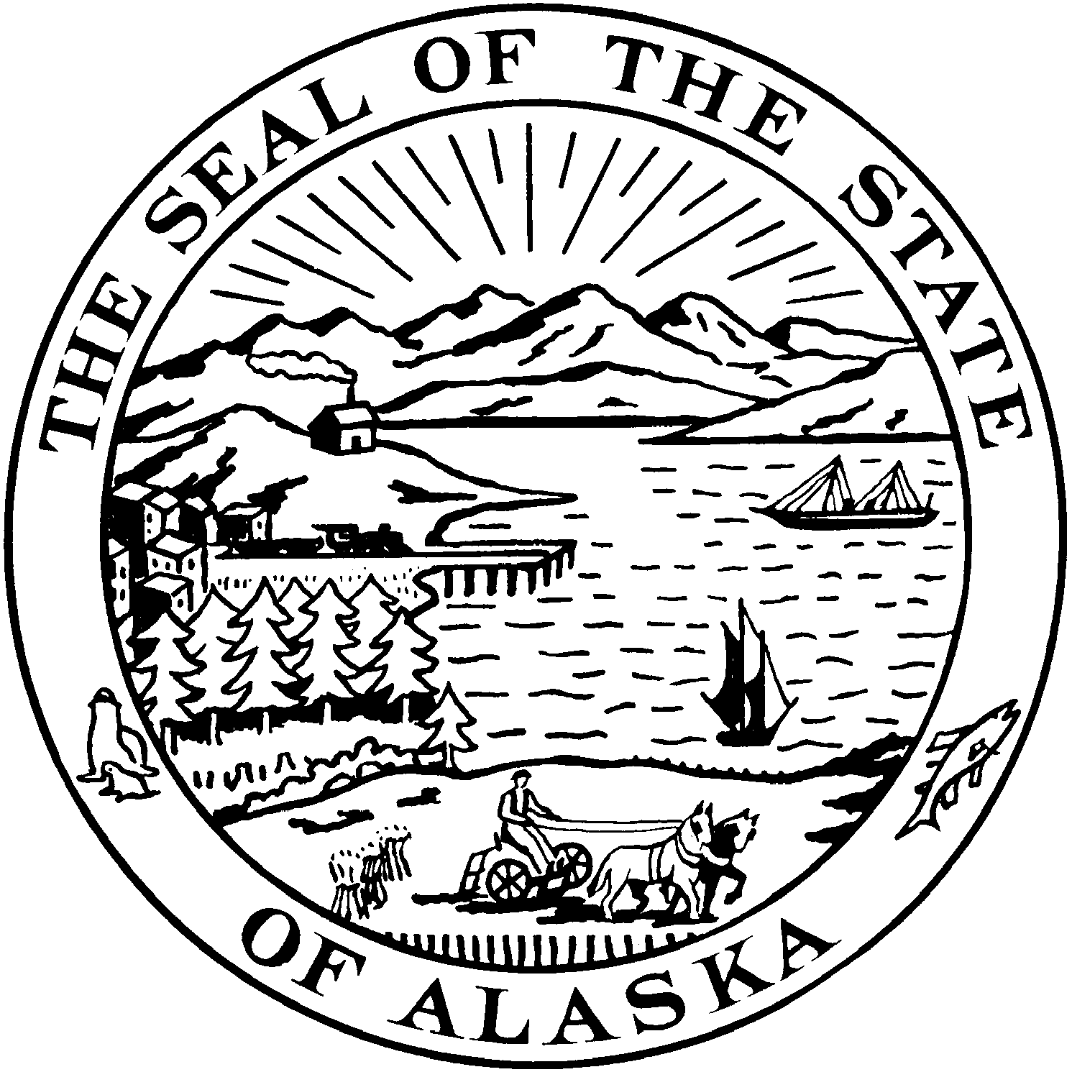
Interim: Session:
301 Santa Claus Lane State Capitol, Room 119
North Pole Plaza Mall Ste. 3B Juneau, Alaska 99801-1182
North Pole, Alaska 99705 Phone: (907) 465-3719
Phone: (907) 451-2063 Fax (907) 465-3258
Fax (907) 451-2332

SENATOR JOHN COGHILL

Date: April 1, 2013
To: Finance Committee Members
From: Sen. John Coghill’s Office
Re: SB 49
Rebuttal to Planned Parenthood and Testimony from Saturday, March 30, 2013
- The testimony was broad and, at times, emotional. That is generally a common trait when debating issues involving abortion.
- Sen. Coghill wants to correct some misunderstandings about the bill including some misunderstandings that come from its opponents.
POINT 1 - PLANNED PARENTHOOD STILL COULD NOT CEARLY DEFINE WHAT AN ELECTIVE ABORTION WAS OR THAT ELECTIVE ABORTIONS EVEN EXIST.
  - Of course, a reasonable person could argue that Planned Parenthood cannot openly clearly admit that elective abortions exist because that would make them elective procedures.
    - As we are all aware elective procedures are not covered under Medicaid.
    - Paying for elective procedures would therefore be an open abuse of Medicaid.
POINT 2 - SB 49 DOES SATISFY EQUAL PROTECTION.
- The 2001 Supreme Court Opinion stated that the State has to provide medically necessary care for women seeking to give birth to a child.
- The court also stated that the State has to provide medically necessary care for women seeking an abortion.
  - What some opponents, even to this day, fail to recognize is the Supreme Court directed that a definition for a medically necessary abortion can be crafted as long as we base it on neutral criteria directly related to the health care program. See tab 4c, Page 16 highlighted portion. That is what SB 49 does. It was based on the very language of the 2001 Planned Parenthood decision and includes direct language found in the federal Hyde Amendment. The conditions are neutral and taken specifically from doctors in the field.
    - One doctor disagreed with the conditions on Saturday. What she may or may not know is that the conditions were overwhelmingly directly taken from the 2001 Planned Parenthood decision.
POINT 3 – SB 49 UNFAIRLY TARGETS POOR WOMEN?
- The US Supreme Court, long ago ruled that the Federal Constitution does not require a State to pay for the costs of elective abortions just because it pays for the costs of childbirth related medical care. See Maher v. Roe, 432 US 464, 474 (1977)
- Additionally, the United States Supreme Court, in 1980, ruled that the Hyde Amendment (which is the foundation for SB 49) does not violate women with lower incomes right to obtain a medically necessary abortion. The case was Harris v. McRae, 448 US 297 (1980). The State has no obligation to remove obstacles that it did not create (namely the woman’s status of being of little means).
POINT 4 – OTHER ATTEMPTS TO LIMIT ABORTIONS SINCE 2001 MAY OR MAY NOT HAVE BEEN SUCCESSFUL.
- SB-49 has nothing to do with those attempts. We cannot comment on the reasons they may or may not have been successful. This is a total different focus. SB-49 is a “lean muscle” bill. We have high confidence in how thorough and specific the bill is drafted.
POINT 5 – SURVIVAL OF FETUS IS NOT CONSIDERED?
- That is simply incorrect. We’ve heard testimony as to the “floating tomb” and the child being “brainless.” We considered that option and incorporated Paragraph 4, B, 22 (See Tab 1). “Another physical disorder…arising from the pregnancy….that would be a major bodily impairment.”
POINT 6 – AN OPPONENT OF THE BILL STATED THAT YOU CANNOT SEPARATE “PHYSICAL HEALTH” AND “MENTAL HEALTH.”
- With all due respect, President Obama via Executive Order 13535, case law, and the very existence of the Hyde Amendment prove otherwise. Sen. Coghill invites you to look at tab 7 in your binders. The language is clear to emphasize “physical disorder”, “physical injury”, or “physical illness.” It specifically does not include mental or psychological disorders.
- In addition, SB 49 supporters, including 3 national doctors and 7 Alaskan doctors fundamentally disagree with that presumption. There is a genuine disagreement in the medical community that mental and psychological conditions should be included under the definition of “medically necessary abortion.”

