Alaska State Legislature

Interim:
50 Front Street, Suite 203
Ketchikan, AK 99901
Phone: (907) 247-4672
Fax: (907) 225-7157
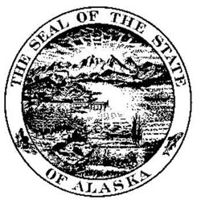

Session:
State Capitol, Room 114
Juneau, AK 99801-1182
Phone: (907) 465-3424
Fax: (907) 465-3793

Representative Kyle Johansen
House District 1

HB 214 - "An Act naming the Ketchikan ferry terminal the Walter L. Kubley Ferry Terminal."

Walter was integral in writing the legislation that created the Alaska Marine Highway System. As the ‘Father of the Alaska Highway System,’ he had fond memories of bringing his family on the maiden voyage of the M/V Malaspina. The ferry sailed from Seattle to Ketchikan in 1963 with Walter’s cousin, Capt. Harold Paine, at the helm and Governor Egan in the wheelhouse.

Walter dove into politics by serving on the Ketchikan City Council from 1957 to 1960. He would be elected twice to the Alaska House of Representatives, serving in the second and third Alaska Legislatures from 1961 through 1964. While in the legislature, Walter became known for his ability to deal with people on both sides on the political aisle in a fair and bipartisan manner. He often said 6 of his greatest years were spent lobbying with his son, Donnie. Together they fought for the same communities and issues that Walter had championed his entire life.

Kubley’s career endeavors made him a trusted confidant to U.S. Senators, Representatives, Governors and State Legislators. His friendship to the late Senator Ted Stevens was one of Walter’s most cherished relationships and he was an honorable pallbearer at the Senator’s funeral services.

Even in retirement, Walter remained active in The Elks, Royal Order of the Moose, Veterans of Foreign Wars and The American Legion. He is remembered as a visionary, a great leader in the state and a dear friend to many.

