Alaska Legislature
House Special Committee on Energy
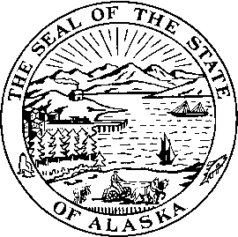

Rep. Charisse Millett Rep. Doug Isaacson
Capitol Building, Room 403 Capitol Building, Room 13
Juneau, AK 99801 Juneau, AK 99801
Phone (907) 465-3879 Phone (907) 465-4527
Fax (907) 465-2069 Fax (907) 465-2197 rep.charisse.millett@akleg.gov rep.doug.isaacson@akleg.org

Agenda
Wednesday, March 20, 2013
8:00 – 10:00 a.m.
Barnes Committee Room (#124)

+Energy Wise Program
Sarah Scanlan, Deputy Director, RurAL CAP, Ellen Kazary, Development Director, RurAL CAP

Bills previously heard/scheduled

* First hearing in first committee of referral
+ Teleconferenced
= Bill previously heard/scheduled

###

