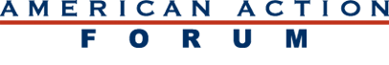

SAM BATKINS

DIRECTOR‚ REGULATORY POLICY

Sam Batkins is director of regulatory policy at the American Action Forum. Batkins focuses his research on examining the rulemaking efforts of administrative agencies and Congress. His work has appeared in The Wall Street Journal, The New York Times, Politico, National Review Online,Reuters, and The Washington Post, among other publications.
Prior to joining the Forum, Batkins worked at the U.S. Chamber of Commerce, Institute for Legal Reform and the National Taxpayers Union. At the U.S. Chamber, he focused on lawsuit abuse, tort reform, and federal regulation. During his time at the National Taxpayers Union, he conducted studies on state and federal spending and published dozens of op-eds.
Batkins received his B.A. in political science from Sewanee: The University of the South, where he graduated summa cum laude and was inducted into Phi Beta Kappa. He received his J.D. from Catholic University of America, Columbus School of Law. He is a member of the Maryland Bar.

