

Early planning, design, engineering key to LNG project success

By:
Bill White
Researcher/Writer, Office of the Federal Coordinator
bwhite@arcticgas.gov
Release Date:
February 19, 2014

Well before big money gets committed to construct a liquefied natural gas export project, sponsors typically spend years studying such questions as: Should this project get built? Does it make business sense? And, as the analysis progresses: Does this project continue to make sense?
The proposed $45 billion to $65 billion Alaska LNG export project is going through that process now.

It's the up-front planning that is critical to megaproject success.
When done well, this pre-construction work can be the reason a project gets built on time and on budget, and creates the kind of cash flow the board of directors was told to expect.
The work goes by different names in different industries. For Alaska LNG, the current work is called pre-FEED — or pre-front-end engineering and design — which will be followed by a more intense FEED phase if the project continues.

During these stages, the project team selects the technology to be used in the production units. It chooses sites for facilities and does initial layouts. Utilities are plotted. Labor needs, particularly skilled-labor needs, get problem solved. Pipeline routing and the related issues — soils, vegetation, river and wetlands crossings — get documented and the best solutions determined. Needed licenses, authorizations and environmental permits are identified and many might even be secured. Markets are assessed and reassessed. A financing plan is defined.
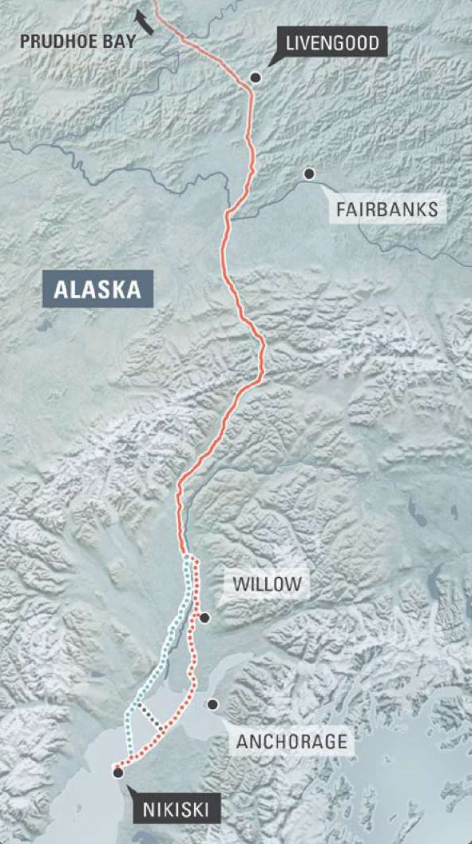
Source: Alaska LNG Project
Part of the Alaska LNG Project gas-pipeline route. The line would feed an LNG plant and export terminal at Nikiski. (Click to enlarge.)
For Alaska, the remote location creates logistical challenges that need detailed planning: Winter-only burial of the 800-mile pipeline because that's when the tundra is frozen; summer-only delivery of massive gas treatment plant modules to the North Slope because that's when Arctic sea ice is absent.

"The definition of a project, from the formation of the core team until full-funds authorization is achieved, is what we call the FEL [front-end loading] process," wrote development guru Edward Merrow in his 2011 book "Industrial Megaprojects: Concepts, Strategies, and Practices for Success."

"FEL is the single most important predictive indicator of project success. There are very few project professionals in the process industries who do not agree with the basic principle that definition and planning drive success, and those who don't should probably be in some other line of work."

Merrow is founder and president of Independent Project Analysis Inc., a major consultancy whose client list includes some of the biggest companies in the world. IPA conducted a megaprojects seminar for Alaska lawmakers in 2011.

"Megaprojects are the most important projects in any industrial company's portfolio," Merrow said in his book.

"When they succeed, the company is strengthened for the long term. When they fail, massive amounts of shareholder wealth can be made to evaporate in a single project."

Even though good up-front planning means better project results, half of all megaprojects in his company's vast database fail to meet that standard, and their failure rate is high. LNG projects do a little better than this average "but not systematically so," he said.

For Alaska LNG, Steve Butt is the man charged with making sure the up-front planning is excellent. He's a career ExxonMobil manager and the senior project manager for this project, having worked stints with ExxonMobil on its big LNG projects in Africa and most recently in Qatar.

"Megaprojects are often defined as projects over $1 billion," Butt told an Alaska Senate Resources Committee on Feb. 3. "In today's world they're sometimes defined as projects over $10 billion. By any metric this is one of the largest megaprojects ever, and in some ways it's really five megaprojects, each one working with each other. ...

"No one has ever permitted a project this large. No one has ever permitted an 800-mile pipeline in the NEPA (environmental impact statement) era in the U.S. No one has ever done an LNG plant this big or a gas treatment plant this big. We'll have to do all three."

HUNDRED-MILLION-DOLLAR QUESTIONS
"Ignorance is the mother of research."
- Laurence J. Peter, founder of the Peter Principle

ExxonMobil owns the largest proportion of North Slope gas that would be produced for the Alaska LNG project, and it is leading the technical team among the four companies scoping the project — North Slope producers BP and ConocoPhillips as well as pipeline company TransCanada are the other three.

ExxonMobil has a reputation for tightly controlling its LNG projects, such as the massive Qatar plants built during the first decade of the 2000s. Its Papua New Guinea project is over budget due to unfavorable currency exchange rates, landowner protests, labor work stoppages and bad weather, but it's still on schedule to start production this year.

"Before we make the first cut with a saw, we re-measure five times instead of one," an ExxonMobil executive said in The Wall Street Journal last month of the company's megaproject planning.

Butt talked with the Alaska Senate Resources Committee about the challenges of the project he is overseeing, including planning a megaproject that needs labor, resources and equipment that can handle Alaska's extreme environment.

"It's so big it creates its own weather, and if we're not careful it competes with itself, because we don't want to have challenges with welders on Part A working at odds or at issues with Part B. So we have to plan this very carefully so we level-load this work, we make sure we get the resources we need for the right craft skills and we don't compete with ourselves. That's very important."

The project is "so big it creates its own weather, and if we're not careful it competes with itself . . .
so we have to plan this very carefully."
- Steve Butt, senior project manager, Alaska LNG

The team he oversees is looking at every detail, to narrow the estimated $45 billion to $65 billion price range and pin it as low in that range as possible.

"We go from really big questions — multibillion-dollar questions — and we just keep grinding it down: Hundred-million-dollar questions, ten-million-dollar questions, million-dollar questions, until we get to such a high level of certainty you move to a place where the investors are ready to make a decision," he said. "They want to know that you've resolved all those uncertainties."
He cited some examples.

The steel for the 800-mile, 42-inch-diameter pipeline would be what's known as X80 — extra-strength steel that, if you extracted a plug from it and strained the plug, could withstand 80,000 pounds of pressure per square inch. Ultra high-end stuff.

"We're looking real hard at the materials," Butt said. "The type of material is really important because it defines the amount of steel in the line and the type of steel in the line, and that tells you who can make it, how many mills can you get it from and what it's going to cost. So one of things we have to study in pre-FEED is the material on that pipeline design. ... Can you go to X70? There's little questions that drive huge value, because this system is so big, any little change you make is hundreds of millions of dollars."

The natural gas produced at Prudhoe Bay — the main field that will feed Alaska LNG — is tainted with about 12 percent carbon dioxide. The project is planning a multibillion-dollar gas treatment plant to extract the CO₂ because it would corrode steel pipe, doesn't burn and LNG buyers don't want it in their gas. Recently Butt's team reconceived the gas treatment plant, streamlining it from an earlier design and syncing it with design of the liquefaction plant to be built 800 miles to the south.

"That's a lot of money we saved," Butt told the committee. "But more importantly, it means the system in the north — with three trains for treating — is now balanced with the system in the south — with three trains for liquefaction. For operations and maintenance over the next 35 years it a much better balanced system. So this is a pretty big achievement for us that we've been working on over the last several months. It's a huge cost savings and risk reduction."

PRE-FEED, FEED PUSH PROJECT AHEAD
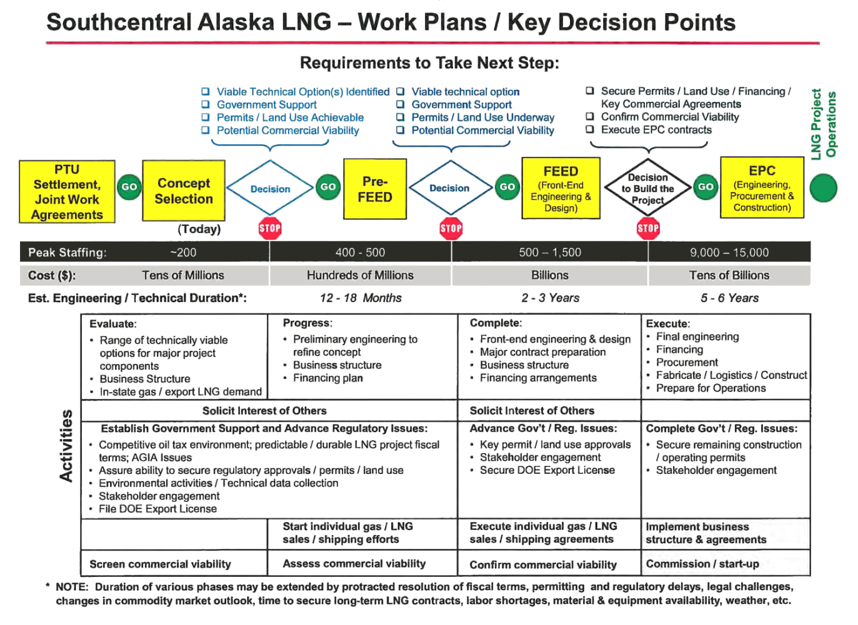
Source: Alaska LNG Project

Graphic from October 2012 outlining the stages and decision points anticipated for the Alaska LNG export project. The project is in the pre-FEED stage currently. (Click to enlarge.)

Officially, people involved with Alaska LNG, including state of Alaska officials, dub the phase the project is currently in as pre-FEED, or pre-front-end engineering and design.

This phase is a precursor to a more formal — and expensive — stage called FEED, which in turn leads up to a final investment decision, or FID, on whether or not to construct the project.
One thing to know about FEED in particular is that this is a term commonly used in the LNG industry but isn't all that universal within the engineering world. Other words cover the same scope of project work — Merrow in a passage quoted above spoke of front-end loading, or FEL, a more common term.

Pre-FEED is starting to get used more widely to describe the LNG project-related activities that occur before FEED — there can be many such activities, so a term for them can be handy.
In the case of the Alaska LNG project, FEED would include:
- Enough engineering of the project so that contracts can be let for final engineering, procurement and construction (called EPC). EPC contracts are where the BIG money gets spent and the project is built.
- Crafting a plan for supplying, commissioning and starting up the Alaska LNG infrastructure — the gas treatment plant, gas pipeline, LNG plant and all related facilities.
- An estimate of the capital costs itemized in sufficient detail that corporate directors charged with making the yes-no final investment decisions are comfortable with their choice.
- A final assessment of environmental, social and health impacts.
- Action on procuring anything for the project that requires long lead times.
These are standard activities during FEED.

Pre-FEED would involve engineering, design, technical and other work needed to prepare for FEED. This includes conducting enough environmental field work and designing the project in enough detail to support applications to the Federal Energy Regulatory Commission for authority to build and operate the project. At a minimum, FERC would oversee the LNG plant construction and possibly the pipeline and gas treatment plant. The commission would produce an environment impact statement as part of its review.

At the end of the pre-FEED stage, each company sponsoring the project would decide if it wants to continue to FEED based on the information gathered so far.

"The purpose of Pre-FEED is to progress technical work that would provide each of the Alaska LNG Parties with sufficient information for evaluating the technical, cost and schedule aspects of the Alaska LNG Project," says the January 2014 Heads of Agreement signed by the state, the three major North Slope producers and TransCanada.

The pre-FEED, combined with other commercial, legal, economic, financial and marketing information, will help all of the parties decide whether to spend billions of dollars on FEED, the HOA says.

Joe Balash, Alaska commissioner of Natural Resources, and Michael Pawlowski, Alaska deputy commissioner of Revenue, told the Senate Resources Committee on Feb. 7 the pre-FEED phase should last up to 18 months and involve about $435 million in spending. Pending Alaska Legislature action before it adjourns in April, the parties committed in the HOA to ramping up pre-FEED in 2014.

The agreement says the FEED decision would occur within three years after pre-FEED ramp-up begins — that could put it at late 2016 or early 2017. Balash and Pawlowski told the Senate committee the more intense FEED stage would span two to three years and roughly estimated it would involve about $1.8 billion in spending. The HOA says FEED would cost "billions of dollars."

IS THAT BIG MONEY?
Now, $2.4 billion in pre-FEED and FEED expenditures that the state of Alaska estimates might sound like BIG money, and it is.

But for a $45 billion to $65 billion project, it's only about 5 percent of the total. It'd be like saying a 10-story building is tall — perhaps in some cities, but not in Manhattan.
Five percent CapEx spending through FEED is about normal for megaprojects, according to Merrow and others.
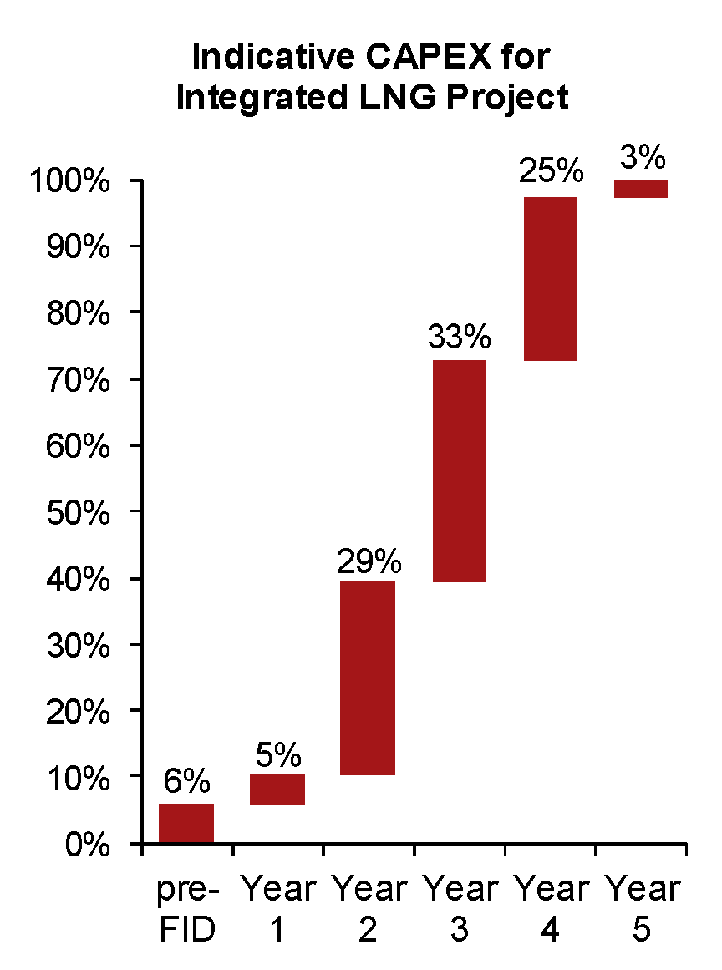
Source: PFC Energy

Pre-construction spending for a typical large LNG project might involve just 6 percent of the overall capital expenditures, with the other 94 percent of spending coming after the final investment decision, or FID, to build the project. (Click to enlarge.)

For LNG projects, figure 6 percent, said Nikos Tsafos of Enalytica Inc., a consultant to the Alaska Legislature on the LNG project, in November 2013. The other 94 percent gets spent after the final investment decision to build. This encompasses all the final engineering, purchase of materials and construction spending. In January, Tsafos loosened his estimate to "less than 10 percent" before FID.

"Before you get to final investment decision, you haven't spent any real money," Tsafos told the Legislative Budget and Audit Committee Jan. 28. "It's not 'real money' in the context of $65 billion.

"The reason this matters (the pre-FEED and FEED spending) is because by the time you get to FID, you haven't resolved but you have found an answer to most of the things you are worried about.

"So it's not the type of project where you put in $65 billion and as you're putting the money down you're thinking, 'Well, how should we do this? Who should we market it to? How should we finance it?' It doesn't work that way.

"By the time the large bulk of that investment takes place, all these things will have been sorted out. Maybe not to a 100 percent. You may not have signed every single deal with everyone. But you'll have a pretty precise idea about what each one of these things (upstream, midstream, liquefaction, shipping, marketing, finance, permitting) are going to look like," Tsafos said.

"So, yes it's a big project, it's a massive project. But the call of capital really comes only after you've had an enormous amount of time to spend to study all the permutations of the options in coming up with a schedule and a project structure that is comfortable to all the project partners."

WHAT CAN GO WRONG?
"It ain't what you don't know that gets you into trouble. It's what you know for sure that just ain't so."
- Mark Twain (some say)

One needn't look hard to find megaprojects that became big messes. Way over budget. Way behind schedule. That didn't work as planned.

Take Denver International Airport, a favorite case study in the annals of project management disasters.

It opened in 1995, 16 months behind schedule and 80 percent — $2 billion — over budget. Its much-touted automated baggage-handling system "became famous for its ability to mangle or misplace a good portion of everything that wandered into its path," as the New York Times put it. The airport scrapped it in 2005, replacing it with humans. A triumph of man over machine.
The textbooks call Denver's failure a classic case of inadequate pre-FID work, of reliance on untested technologies, of "optimism bias." And, a flaw that sometimes infects big-ticket public works projects that politicians really want. It's called "strategic misrepresentation" — the cloaking of true costs from the public for fear they would rebel.

Other favorite examples: Boston's Big Dig tunnel — original budget $2.8 billion, ultimate cost $22 billion — and the Chunnel connecting England and France — 20 percent late; 80 percent more expensive than forecast.

Among LNG projects, the Chevron-led Gorgon project under way off Australia's west coast is more than 40 percent over budget as the sponsors endure a trickier environment, and costlier labor and materials than expected, as well as an unfavorable exchange rate and some acutely nasty cyclones. These are all issues that developers try to foresee and address during pre-FEED and FEED.

Angola LNG was supposed to start up in 2012. It finally shipped its first load in July 2013, more than a year behind schedule. Chevron is a partner here, too, and the CEO said Jan. 31, 2014, "we have had some technical issues on the front end of that plant." Likely the plant will operate at just half capacity in 2014 and ideally will hit full capacity sometime in 2015, he said.

MONEY WELL SPENT
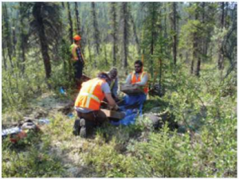
Source: Alaska LNG Project
An Alaska LNG field crew working in northern Alaska along the proposed gas pipeline route during the 2013 summer.

In his book, Merrow said a project with severe and continuing production problems in its initial years is a failure by definition.

After spending billions or tens of billions upfront on megaprojects, the corporate board wants its payoff, and that starts the moment the plant gets switched on. A late start or a slow start mean a lot less cash inflow than the directors were told to expect.

"The early years' production are the most valuable the project will ever have," Merrow said. When lost, they're lost for good.

Although there are no ironclad laws about these things, there are some general rules of thumbs circulating in the industry's literature about what constitutes a problem project besides start-up production problems: big cost overruns or big schedule slips — say 25 percent beyond what they should be.

"Megaproject results are frequently seriously short of the expectations of the sponsor-investors," Merrow wrote. "Their cost overruns are often so significant that the whole project becomes NPV negative."

Negative NPV — or net present value — does not mean unprofitable, it should be noted, but rather that the return on investment is below the investor's requirements.

"The real question is whether the investment you made up-front is optimal or not, or whether having put that money elsewhere would have generated a better return. So it's not really usually about losing money. It's about the optimal use of money," Tsafos explained to the Alaska Legislative Budget and Audit Committee in January 2014.

Megaprojects whose pre-FEED and FEED are well done — Merrow calls these stages FEL-1 through FEL-3 — have good track records for producing plants that operate as expected, according to his company's database.

Megaprojects are headed for trouble if the partners' interests are out of sync, if they skimp on pre-FEED and FEED staffing, if they're under such schedule pressure that corners get cut, if they short-change upfront planning because it can be expensive.

"We hear things like, 'Why should it cost so much money? I once front-end loaded a big project on a napkin over a beer.' If you are the project director, now would be a good time to post your resume," Merrow said in his book.

"Doing a thorough job defining and planning an industrial megaproject takes 3 to 5 percent of eventual total capital cost. Let's be clear; on a megaproject that is a lot of money. The cost, however, of not spending the money is much, much more."

-By Bill White, Researcher/Writer for the OFC. bwhite@arcticgas.gov

http://www.arcticgas.gov/early-planning-design-engineering-key-lng-project-success

