28th Alaska State Legislature

Senator John Coghill, Chairman
State Capitol Building
Room 119
Juneau, AK 99801-1182
(907) 465-3717

Senator Lesil McGuire
Vice-Chair
State Capitol Building
Room 103
Juneau, AK 99801-1182
(907) 465-2995

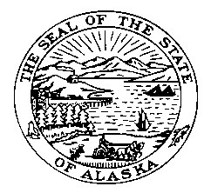

Senate Judiciary Committee

SPONSOR STATEMENT
Omnibus Crime/Corrections Bill
CSSB64 (STA) – Version O

Senate Bill 64 implements proven-practices to reduce recidivism and cut the cost of corrections while maintaining public safety.

Main sections of this bill:

Criminal Justice Commission: This bill will establish a Commission that is intended to review, analyze and evaluate the effect of sentencing laws and practices of the criminal justice system. The Commission will be made up of members from the legislature, state agencies, retired and active judges, as well as other participants around Alaska.

Limited Licenses: SB 64 permits eligible therapeutic court participants (for DUI or refusal) the opportunity to receive a limited license with successful adherence to program requirements. These sections make changes to statutes affecting misdemeanor and felony DUI or refusal offenders. The intent is that a therapeutic court or treatment program will assist offenders and incentivize them to receive treatment.

Probation and Parole Accountability with Enforcement: There are new duties for the Commissioner of the Department of Corrections, and the Parole Board. The Commissioner and Parole Board shall establish a drug testing program for eligible offenders. The program requires a probation or parole officer to file a petition to revoke probation or parole if the person fails to appear, tests positive for controlled substances or alcohol, or fails to follow any condition ordered by the court.

