Alaska State Legislature

SENATOR DONALD C. olson
Chair
Community & Regional Affairs
Member
Senate Finance Committee
Ethics Committee
Legislative Council
Northern Waters Task Force
Education Funding District Cost Factor
Finance Subcommittee Chair
Fish & Game
Health & Social Services
Public Safety
Finance Subcommittee Member
Environmental Conservation
Session
Alaska State Capitol, Rm. 508
Juneau, AK 99801
(907) 465-3707
Fax: (907) 465-4821

Interim
716 W. 4th Ave. Ste 530
Anchorage, AK 99501
(907) 269-0254
Fax:(907)269-2031

Senator_Donny_Olson@legis.state.ak.us
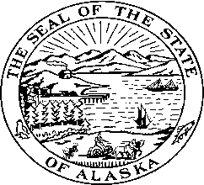

SB 226 - PURCHASE & LEASE OF NOME STATE OFFICE BUILDING
Sectional Analysis

SECTION 1 Findings & Purpose.

SECTION 2 Directs AHFC to finance the purchase of an office building in Nome, from Nome.

SECTION 3 Directs DOA to enter into a lease-purchase agreement for the building.

SECTION 4 Legislative approvals of financing & lease-purchase agreement.

SECTION 5 Effective date.

