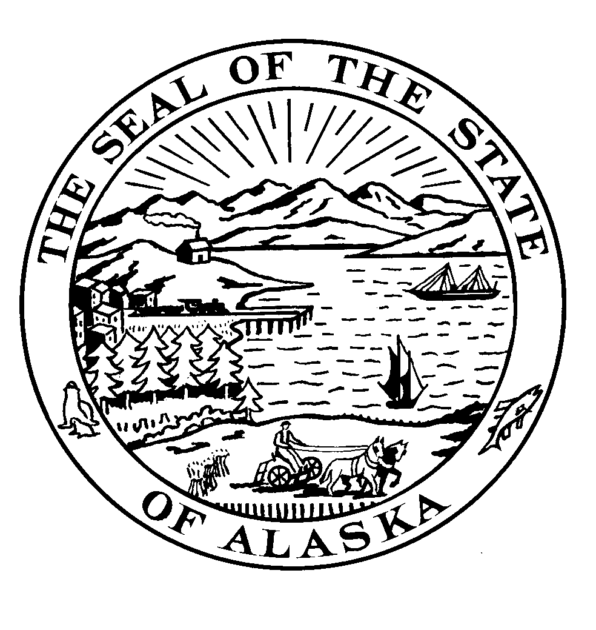

Alaska State Legislature

SESSION ADDRESS:
Alaska State Capitol
Juneau, Alaska 99801
Phone: (907) 465-3743
1-800-565-3743
Fax: (907) 465-2381

INTERIM ADDRESS: 600 E Railroad Avenue Wasilla, AK 99654 Phone : 907-376-3725 Fax: (907) 376-4768

Representative Carl Gatto

TO: Representative Wes Keller, Chair
House HSS Committee
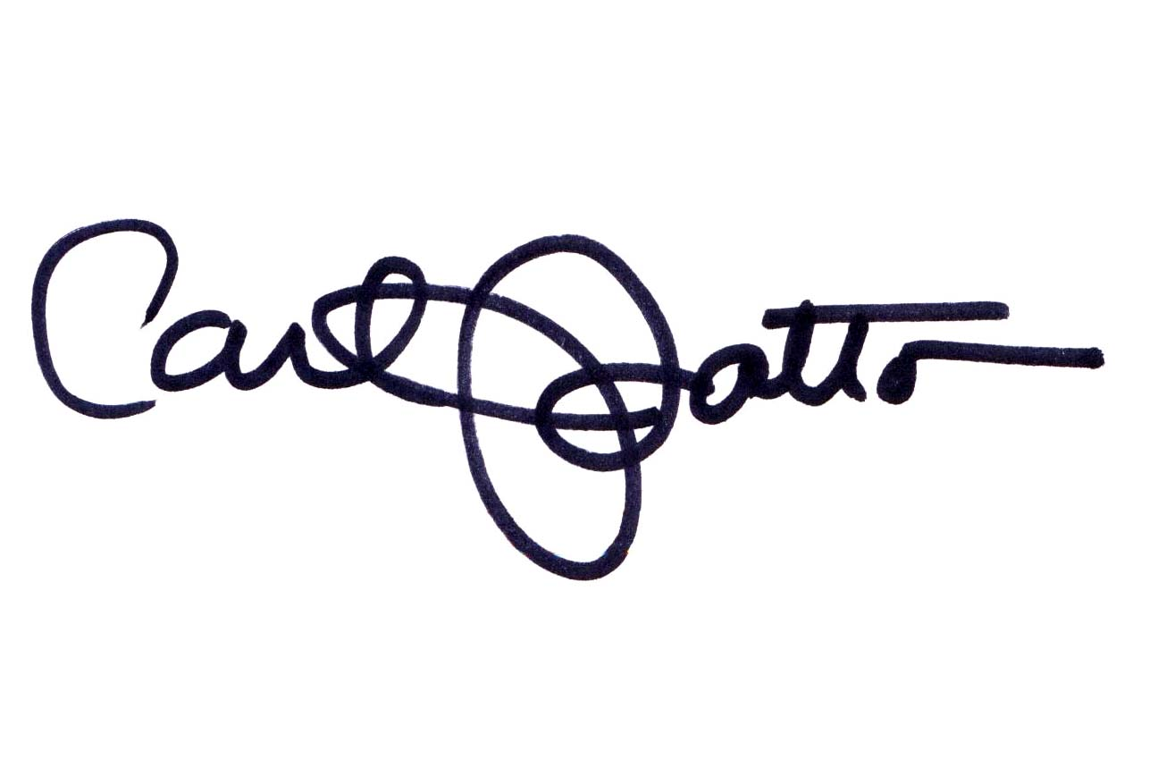
FROM: Rep. Carl Gatto

DATE: February 23, 2011

RE: Request for a hearing of HB 1

Enclosed is the committee packet for HB 1, an Act stating a public policy that allows a person to chose or decline any mode of securing health care services,” also called “Alaska Health Freedom Act”. I have included a sponsor statement, the original version of the bill, and other supplemental material.

I would appreciate a hearing before your House HSS Committee at your earliest convenience. I appreciate your time and look forward to your reply.

Please contact my staff member, Karen Sawyer at 465-5025, with any questions or comments regarding this request.

Thank you for your consideration.

