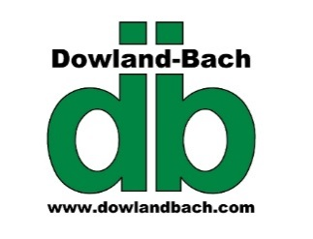
Dowland-Bach Corporation
Physical: 6130 Tuttle Place, Anchorage, AK. 99507
Mailing: PO Box 230126, Anchorage, AK 99523
Tel: 907/562-5818 Fax: 907/562-5816
www.dowlandbach.com

Lynn@dowlandbach.com
April 6, 2015

House Resources Committee
Co-Chair Rep. Ben Nageak
Co-Chair Rep. David Talerico
Vice-Chair Rep. Mike Hawker

RE: HB100- Urea/Ammonia Facility Tax Credit

Dear House Resources Committee:

Dowland-Bach is a forty year old Alaska based manufacturing, distribution and automation services firm based in Anchorage. Our primary clients are the oil and gas industry in Alaska and around the world. We are one of Alaska’s relatively few manufacturing entities, building controls systems, UL control panels and production and chemical injection skids and modules for industry in Alaska. Our company benefits both directly and indirectly from increased resource development in the form of continued jobs and manufacturing and distribution services.

I am writing to express Dowland-Bach’s support of HB100 – Urea Facility Tax Credit. Specifically:

Jobs: With oil and gas prices low, job losses are beginning to occur in the oilfield. This bill could have a significant impact on Agrium’s work to restart their plant, which has numerous benefits for the entire Alaska economy.

Business: The impact of an Agrium restart is not just about the people working on the plant in Kenai. The overall cash infusion and indirect jobs across Alaska would be dramatic and important for the entire State. Cook Inlet has rebounded and customers like Agrium, as a steady customer, would insure that this continues.

In summary, I am fully supportive of the intent of this bill and respect your diligence in moving this forward in the best interest of Alaska’s economy.

Sincerely,

Lynn C. Johnson
Chairman, Dowland-Bach Corporation

