### ALASKA STATE SENATE

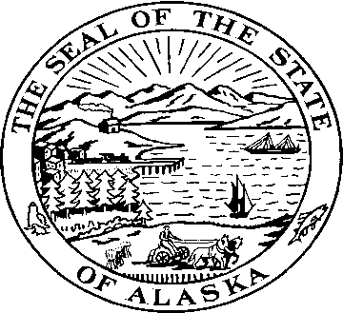

**Sen. Kevin Meyer Sen. Joe Thomas**

Alaska State Capitol Alaska State Capitol

Juneau, Alaska 99801 Juneau, Alaska 99801

Room 103 Room 514

Phone: 907-465-4945 Phone: 907-465-2327  
Fax: 907-465-3476 Fax: 907-465-5241

### SENATE EDUCATION COMMITTEE

### Senators Kevin Meyer & Joe Thomas, Co-Chairs

**Senate Bill 83**

**"An Act providing for payment and loan incentives to public school teachers for national board certification."**

*…teaching is work of the most demanding sort, for teachers must make dozens of decisions daily, command a wide body of knowledge and skill, learn to react instantly, and be disposed to act wisely in difficult situations. And while there are principles and precepts, skills and techniques, to guide the work, teaching is also an activity with artistic aspects, a craft calling for reflection and judgment.*

----From *What Teachers Should Know and Be Able to Do*

Teaching is one of the most difficult and important jobs we have in our society. In order to have good schools, we must have good teachers.

Senate Bill 83 provides an incentive for teachers to ramp up their professional knowledge and skills by becoming nationally certified by the National Board of Professional Teaching Standards. Teachers would be provided with zero interest loans designed to pay the expense of enrolling in the program. Once certified they would receive a $1,000 annual stipend for the duration of their certification period (ten years).

If the teacher is serving in a low performing, high poverty area they would receive a $1,000 stipend for enrolling in the program, and $1,500 loan for the rest of the expense. They would also receive an additional $500 annually as long as they remained in a low performing, high poverty area.

Becoming nationally certified is a rigorous and demanding process, and can take up to three years. There are 25 different areas of certification (see page 7 of the packet), and teachers specialize in their specific subject area. The certification process focuses on five aspects of teaching: Students and their learning, the subjects being taught and how to teach them, managing and monitoring student learning, thinking systematically about the practice of teaching, and being members of the learning community.

We appreciate your support on this important bill.