Alaska State Legislature

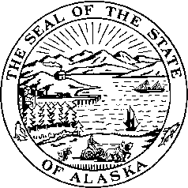

*Interim:*  S*ession:*

716 West 4th Ave. State Capitol Building

Anchorage, Alaska 99501 Juneau, Alaska 99801-1182

(907) 269-0199 (907) 465-4945

## Legislative Budget & Audit Committee

# SB 262 SPONSOR STATEMENT

**TITLE**: “An Act extending the termination date of the Board of Social Work Examiners;

and providing for an effective date.”

The Board of Social Work Examiners (BSWE) was established for the purpose of controlling and regulating the practice of social work in the State. A licensed social worker applies social work principles and methods, as defined by AS 08.95.990(7), to help individuals achieve more adequate, satisfying, and productive social adjustments.

BSWE is composed of five members appointed by the Governor. Statutes requires that one board member be a licensed baccalaureate social worker, one a licensed master social worker, two members be licensed clinical social workers, and one be a member of the general public.

In the opinion of Legislative Audit, the BSWE should continue to regulate clinical, master, and baccalaureate social workers. The board is serving the public interest by promoting the competence and integrity of those who provide services to the public as licensed social workers. BSWE continues to enforce and propose changes to regulations to improve BSWE’s effectiveness and ensure that social workers are appropriately licensed.

SB 262, if enacted, would extend the Board for eight years to June 30, 2018.