Alaska State Legislature

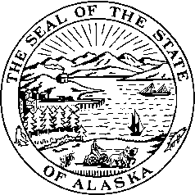

*Interim:*  S*ession:*

716 West 4th Ave. State Capitol Building

Anchorage, Alaska 99501 Juneau, Alaska 99801-1182

(907) 269-0199 (907) 465-4945

## Senator Kevin Meyer

Senate District O

CSSB 151 FASD AS A MITIGATING FACTOR IN SENTENCING

Explanation of Changes

SHSS

From version X to O

* Removal of Section 1 which set out a definition of mental disease or defect.
* Section (18) there has been some debate over previously convicted felons, how this can be applied.
* Addition of section (20) which adds FASD as a mitigating factor, defines it and sets out how it can be diagnosed.

SJUD

From version O to U

* Section (18), page 3, lines 13-14 has been deleted, which makes this mitigator applicable to felons, however crimes against a person are not eligible for a mitigating factor.
* Section (20), page 3, line 30 has been deleted. It is not outlined for other mitigating factors how mental disease or defect is determined. This can be done as it is now; through clear and convincing evidence, the court can find someone to be suffering from a mental disease or defect.