Alaska State Legislature

Senate Majority Leader

Judiciary Committee
Chairman
In-State Energy Committee
Co-Chair
State Affairs Committee
Joint Armed Services Committee
Legislative Council
Rules Committee

Session Address:
State Capitol, Room 119
Juneau, AK 99801-1182
(907) 465-3719
Fax (907-465-3258

Interim Address:
1292 Sadler Way, Suite 340
Fairbanks, AK 99701
(907) 451-2997
Fax (907) 451-3526
877-465-3719

www.aksenate.org
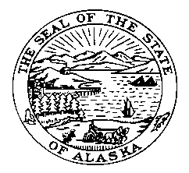

Senator John Coghill

Alaska Administrative Code

Chapter 54
Administration

Article 1
Privacy of Client Records: Child Protection Services
7 AAC 54.020. Information to be safeguarded (a) Child protection information to be safeguarded under 7 AAC 54.010 - 7 AAC 54.150 by the department is information contained or described in the department's child protection files and includes the following:
(1) names and addresses of applicants and recipients of child protection services from the department;
(2) information contained in applications, reports of investigations, evaluations, protected health information, correspondence and court reports, and other information concerning the condition or circumstances of any person about whom information is obtained, whether or not this information is recorded;
(3) department evaluations of and action taken on the information; and
(4) the identity of a person who reports child abuse or neglect. (b) Notwithstanding (a) of this section, the department may share the name and photograph of a child under AS 47.10.090(d) to assist in the recruiting or location of a permanent placement of a child following the termination of the parental rights to the child.

