### ALASKA STATE SENATE

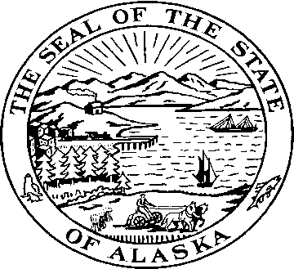

**Sen. Kevin Meyer Sen. Joe Thomas**

Alaska State Capitol Alaska State Capitol

Juneau, Alaska 99801 Juneau, Alaska 99801

Room 103 Room 514

Phone: 907-465-4945 Phone: 907-465-2327  
Fax: 907-465-3476 Fax: 907-465-5241

### SENATE EDUCATION COMMITTEE

### Senators Kevin Meyer & Joe Thomas, Co-Chairs

**Senate Bill 84**

**"An Act relating to funding for high school vocational education as a component of funding for public schools; increasing the base student allocation used in the public school funding formula; and providing for an effective date."**

*The legislature shall by general law establish and maintain a system of public schools open to all children of the State, and may provide for other public educational institutions.*

In our country we have accepted a daunting challenge—to provide a quality education to every single child in our nation. For Alaska this is an especially daunting task. The immensity of the state combined with the small scale of many communities poses challenges no other state faces, especially in the economic arena.

In 2008 the 25th Legislature saw fit to pass an annual $100 increase to the Base Student Allocation for three consecutive years to ensure stable and adequate funding of education. 2011 is the last of that three-year cycle. The legislature also revisited funding for intensive needs special education, and provided equitable funding for this program, and incorporated new district cost factors to provide equitable funding across the state. The foresight of the Legislature on these two issues is commendable, and should be emulated by future legislatures.

To that end we are introducing SB 84, which establishes incremental three-year increases in the BSA and sets aside funds for high school vocational education. This additional annual amount added to the BSA allows schools to keep up with the rising cost of educating our children. The incremental increases represent less than two percent a year, which is below the current inflation rate.

This bill also sends a clear message to the school districts—this is the amount they will have to work with for the next three years. It allows them to act in fiscally responsible ways by giving them financial parameters for the next three years.

SB 84 also establishes a vocational education factor in the school funding formula. Currently vocational education is combined with bilingual, gifted and talented and special education. Legal mandates require districts to offer certain special education programs, and often those required programs take huge amounts of money, leaving little left over for vocational education.

Throwing money at the educational issues in our state will not solve our problems, but neither will allowing inflation to erode two to three percent of funding every year.

SB 84 is a moderate and responsible piece of legislation designed to provide funding, stability and predictability so school districts can concentrate on the essential work of improving educational outcomes.

We urge you to support this important bill.