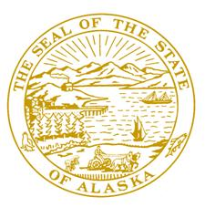
Session:
Alaska State Capitol
Juneau, AK 99801-1182
Phone: (907) 465-2679
Fax: (907) 465-4822
Toll Free (800) 505-2678

Interim:
600 E. Railroad Ave
Wasilla, AK 99654
Phone: (907) 376-2679
Fax: (907) 373-4745

Member:
House Finance Committee

Chair:
House Budget Sub Committees on:
- Department of Health & Social Services
- Department of Transportation & Public
Facilities

Alaska State Legislature

Representative Mark Neuman
Rep.Mark.Neuman@akleg.gov

Sponsor Statement

Alaska Statutes already recognize that we have a right to use deadly force to protect our family, person, and property. HB 24 further clarifies that right exists not only in our home but also in any other place that we have a right to be.
This legislation clarifies the individuals’ right to stand their ground and not second guess the consequence of protecting their family or self.
HB 24 strengthens the legal recognition of a basic human right to defend oneself, by sending a message to the Judiciary and Law Enforcement that it is the criminal who has the duty to retreat.

