Alaska State Legislature

Juneau
State Capitol Bldg., Rm. 104
Juneau, AK 99801-1182
Phone (907) 465-4527
Fax (907) 465-2197

Representative.alan.dick@legis.state.ak.us

Interim
1292 Sadler Way, Ste 328
Fairbanks, AK 99701
Phone (907) 452-3434
Fax (907) 452-3430
Toll-Free (800) 491-4527

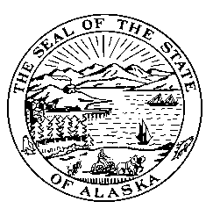

Representative Alan Dick
House District 6

Sponsor Statement
CS HB 256 (EDC): School District Intervention
CS HB 256 incorporates:
- Information from the recently settled Moore v. State of Alaska case,
- Input from our hearings on the original bill,
- responses from the Department of Education and Early Development (DEED), and
- Consultation with highly qualified individuals like former Commissioner Jerry Covey.
The intent of CS HB 256 is to ensure that the DEED establishes and maintains a healthy, helpful relationship with all school districts, but particularly any school or district whose performance is below standard.
Safeguards are built into this bill that speak specifically to accountability and improvement for the Department as well as the districts. Districts with over 50% Alaska Native populations can be certain that local and cultural concerns will be met when improvement strategies are being developed.
Every element of CSHB 256 speaks to specific needs as expressed by districts in their relationship struggling with DEED while struggling with student performance. The final outcome should be improved services to students and a clearer pathway to help all Alaskan schools in need of assistance.
Simply put, this requires the Department and the districts to cooperate and collaborate for the benefit of Alaska’s students. How unfortunate that we have to put that in statute.

