March 1, 2015

Senator Pete Kelly, Senate Finance Co-Chair
Senator Anna McKinnon, Senate Finance Co-Chair

I have attached our Position Paper addressing our concerns and recommendations regarding marijuana legislation, currently in the form of SB 30 scheduled for the Senate Finance Committee. Recent meetings by our legislative committee raised additional, significant concerns about the bill in its current form that were not addressed in our Position Paper:
- There is no felony conduct related to marijuana left, according to this bill. While we understand that some conduct is legal, and other conduct gets lower penalties than before, there still must be a felony on the books to deal with large scale dealers and growers engaged in criminal enterprise. A misdemeanor conviction is of no deterrent value, and more severe penalties must be afforded to judges for these large scale operations.

- As currently written, everything over 25 plants is a misdemeanor, and possession of up to 25 plants is simply a violation. In fact, there is little to no incentive to limiting home grows to no more than six plants. Without adequate deterrent penalties, these limits are likely to be routinely exceeded and with little regard for the minor consequences by offenders.

- Even though the initiative made possession of more than one ounce of marijuana (and marijuana products) being illegal, there are no penalties in the current version of the bill we heard Friday. There need to be some product weights to go alongside the plant count. We recommend something along the following lines: 7-24 plants and 1-4 ounces = Class B misdemeanor; 25-99 plants and 4-16 ounces = Class A misdemeanor; 100 plants and up, or more than 16 ounces = Class C felony. This is simply an example of how these amounts could be related, with more appropriate penalties, and we recommend the legislature classify them appropriately.

- Unlike alcohol (Class A misdemeanor/Class C felony), providing marijuana to a minor is nothing more than a violation, which is an unnecessarily lenient penalty and does not support the current broad support for keeping marijuana out of the hands of our youth, especially given the scientific findings of damage it does to developing brains. Providing marijuana to a minor should be a serious criminal act with appropriate penalties.

Thank you for your attention, and please contact AACOP at any time for additional information or clarification. The AACOP Position Paper is attached.

Sincerely,
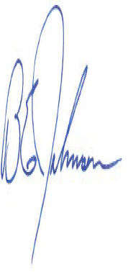

Brad Johnson, Deputy Chief Fairbanks PD
President

