State of Alaska
Department of Revenue
Administrative Services Division
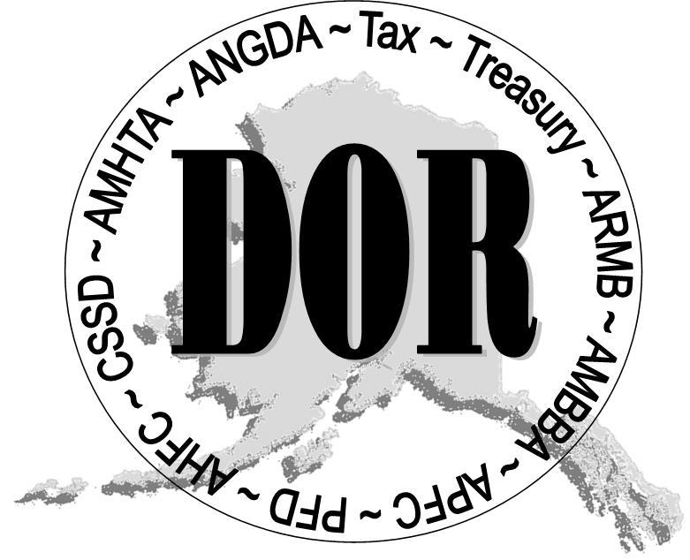
SEAN PARNELL, GOVERNOR
333 Willoughby Avenue, 11th Floor
P.O. Box 110400
Juneau, Alaska 99811-0405
Phone: (907) 465-2300
Fax: (907) 465-2394

January 20, 2010

The Honorable Albert Kookesh
Senate Transportation Committee
Alaska State Legislature
State Capitol
Juneau, AK 99801

Dear Senator Kookesh:

Senate Bill 218 was read across the floor on January 19, 2010 and transmitted to the Senate Transportation Committee for consideration. I respectfully request a hearing to be scheduled at your earliest convenience for the motor fuel tax suspension to be discussed.

This bill requests that the motor fuel tax be suspended for a period of two years beginning July 1, 2010. Alaskans are facing increased food, fuel and other living costs and the financial burden for many families is difficult to manage. The actual amount of money saved by suspending the fuel tax would vary depending on the type of fuel purchased; however, most consumers should save eight cents per gallon when filling up their vehicles.

If the Committee requires any additional information, please contact me.

Sincerely,

Ginger Blaisdell
Director

