The Honorable Grier Hopkins
Alaska State Legislature

February 10, 2020
RE: HB232 - An Act relating to a municipal air quality improvement tax credit; and relating to a municipal energy efficient new construction tax credit.

Dear Representative Hopkins,
Thank you for sponsoring HB232, and to Committee members for their consideration. As you are aware, AML responds to the needs of Alaska’s 165 cities and boroughs, which are political subdivisions of the State of Alaska. We are a member-service organization and work to strengthen local governments across the state.
Our membership is diverse, and a broad difference between home rule and first-class boroughs and cities, and second-class cities and boroughs. The latter, in particular, are limited by what the State of Alaska allows or prohibits. HB232 essentially allows for second-class cities and boroughs to adopt additional powers if they so choose.
Without commenting on value of air quality improvements or energy efficiency in new construction, it is important to recognize that this value needs to be determined at the local level. HB232 is responsive to the needs of local governments by providing them the option of additional tools as they deem necessary, and as they relate to air quality and energy efficiency.
AML appreciates the recognition of the bill sponsor of these important elements of local control and for empowering local governments as they work to meet the expectations and needs of residents.
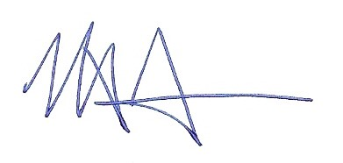
Respectfully,
Nils Andreassen
Executive Director

