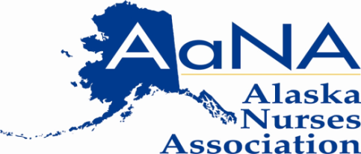
3701 E. Tudor Road, Suite 208
Anchorage, Alaska 99507
(907) 274-0827
www.aknurse.org

Testimony of Susan Walsh, RN
President, Alaska Nurses Association
SSSB8; An Act establishing procedure and guidelines for auditing pharmacy records
March 28, 2013
Senate Labor and Commerce

Mr. Chairman and committee members, my name is Susan Walsh and I am a registered nurse and resident of Ketchikan Alaska. Today I am testifying on behalf of the Alaska Nurses Association in support of SSSB8.

As a registered nurse from Ketchikan I can attest to how important pharmacies like our Island Pharmacy in Ketchikan are not only to our local patients, but also to persons living on Prince of Wales Island.

In recent years auditors from insurance companies, and other third party payers, seem to have become excessive in the tactics they use in auditing Alaskan pharmacies. There currently are no rules and regulations governing the practices of these auditors, and so our local pharmacies are being can potentially be charged large sums of money for simple errors that are clerical in nature and not acts of fraud. I am afraid that if these audit practices continue unchecked we will one day go to have our prescriptions filled and find there is no one left in business to do so.

We think the SSSB8 does a good job of setting out the ground rules for pharmacy audits so that they are conducted fairly and for the purpose of identifying true fraud.

