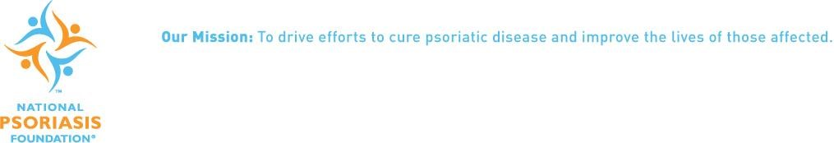

February 6, 2017

Senator David Wilson
Chair, Senate Health & Social Services Committee
State Capitol Room 103
Juneau AK, 99801

RE: Support SB 32 – Prescriptions for Biological Products

Dear Senator Wilson:

The National Psoriasis Foundation (NPF) is a non-profit, voluntary health agency dedicated to curing psoriatic disease and improving the lives of those affected. The Psoriasis Foundation is the leading patient advocacy group for the 8.3 million Americans and 25,800 Alaskans living with psoriasis and psoriatic arthritis.

The introduction of biologic products for the treatment of psoriasis and psoriatic arthritis has been the most significant advancement in care for the psoriasis and psoriatic arthritis community in recent decades. Biologics have provided some patients with an effective therapy—many for the first time in their lives. While the community welcomes new and affordable treatments, patients with psoriasis and psoriatic arthritis are keenly aware of the risks associated with biologics, including suppression of the immune system and the lack of long-term safety data for new treatments.

In contrast to the case with generic drugs, which are chemically identical to their branded counterparts, biosimilars are not chemically identical to their branded biologics counterparts because, as large, complex molecules derived from living cells using recombinant DNA technology, biologics can never be exactly replicated due to their inherent variability. The NPF believes that legislation concerning biologics is both an access and safety issue and neither should be sacrificed for the other, a balance can and has been found. As the committee considers this legislation we urge you to report this measure favorably with the communication provision intact.

Sincerely,

Randy Beranek
President & CEO

CC: Members, Senate Health & Social Services Committee
Members, Senate Labor & Commerce Committee

