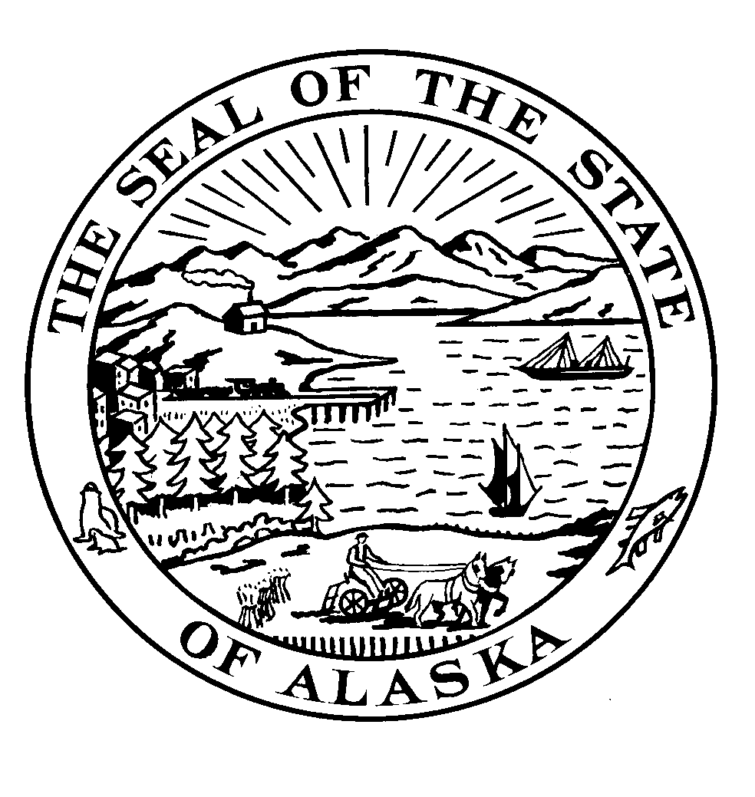

Alaska State Legislature

INTERIM ADDRESS: 600 E Railroad Avenue Wasilla AK 99654 Phone: 907-376-3725 Fax: 907-376-4768

SESSION ADDRESS:
Alaska State Capitol
Juneau Alaska 99801
Phone: 907-465-3743
1-800-565-3743
Fax: 907-465-2381

Representative Carl Gatto

HB 1 Alaska Health Freedom Act

The Alaska Health Freedom Act codifies as state policy that every person in the state of Alaska is and shall continue to be free from government compulsion in the selection of health insurance options, and that such liberty is protected by the Constitutions of the United States and the State of Alaska. The bill removes the authority of any state official or employee from enforcing any penalty which violates the policy. HB 1 affirms the right of all Alaskans to choose their own “mode of securing health care services.”

We allege that the new federal law, Patient Protection and Affordable Care Act (PPACA), infringes upon the constitutional rights of U.S. individuals by mandating all citizens and legal residents have qualifying health care coverage or pay a tax penalty. By imposing such a mandate, the law exceeds the powers of the United States under the Constitution.
There are currently at least 40 state legislatures who have introduced legislation to limit, alter or oppose selected state or federal actions, including single-payer provisions and mandates that would require purchase of insurance. Please help Alaska join three states, Idaho, Georgia, and Missouri, who enacted legislation in 2010 to establish the individual’s right in their state to be free from government force to make their own choice about health care.

Contact: Karen Sawyer
465-5025
27-LS0006\A
February 22, 2011

