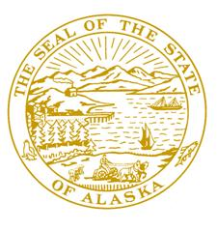
Session:
Alaska State Capitol
Juneau, AK 99801-1182
Phone: (907) 465-2679
Fax: (907) 465-4822
Toll Free (800) 505-2678

Interim:
600 E. Railroad Ave
Wasilla, AK 99654
Phone: (907) 376-2679
Fax: (907) 373-4745

Member:
House Finance Committee
Legislative Budget & Audit Committee

Chair:
House Budget Sub Committees on:
- Department of Administration
- Department of Labor and Workforce
Development

Alaska State Legislature

Representative Mark Neuman
Rep.Mark.Neuman@legis.state.ak.us

House Bill 158 Sponsor Statement

House Bill 158 amends the Knik Arm Bridge and Toll Authority’s enabling statute to provide for a successful procurement for the Knik Arm Crossing project and to generate the best value for the state. Passing this legislation this session is important to seeing the Knik Arm Crossing efficiently move toward a successful and low-cost procurement process and facilitate being open for traffic in 2015. The Knik Arm Crossing will be a significant addition to Alaska’s infrastructure that will further facilitate the movement of goods and people in the state.
This bill was written in consultation with the Knik Arm Bridge and Toll Authority (KABATA), which was established in 2003 by the Alaska Legislature. The bill accomplishes many items KABATA has deemed necessary to have a successful public-private partnership procurement. Those items are:

- Increase in KABATA’s Bonding Authority from $500 million to $600 million
  - The $600 million number represents the same amount authorized under Private Activity Bond (PABs) allocation from FHWA
  - Lowers the cost of capital for the project and ultimately lowers the cost to end users
  - Private partner is the borrower of any PABs issued.

- Property tax relief – clarify that the Crossing and associated facilities are exempt from state and local property taxes
  - Like any other transportation project in our State, the roads and bridges are not subject to property taxation.
  - Any private facilities developed outside the crossing will be taxable
  - Property tax exemption reduces the availability payment and reduces the toll
- Contractual Monetary Obligations
  - Identifies the *obligations of the State of Alaska* under a P3 process
  - The legislative language applies to “monetary liabilities” which may be incurred by KABATA under a P3 process
  - Any P3 agreement needs to be approved by the KABATA Board of Directors, State AG’s office, ADOT&PF
  - Serves to lower the cost of debt and equity to finance the project
  - Keeps the tolls affordable to the traveling public

Project reserve
  - Creation of a reserve fund is to provide a backstop for toll revenue fluctuations.
  - Serves to enhance the credit worthiness of the project and reduce overall project costs
  - Will be repaid over the project life

All of the above language clarifications and additions serve to lower the cost of capital on this much needed infrastructure project and deliver the benefits in a timely and efficient manner.

Please help me by supporting this legislation so a long-term, long sought after project can be realized.

Sincerely,
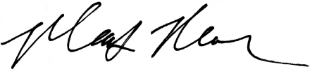
Representative Mark Neuman

