ALASKA STATE SENATE

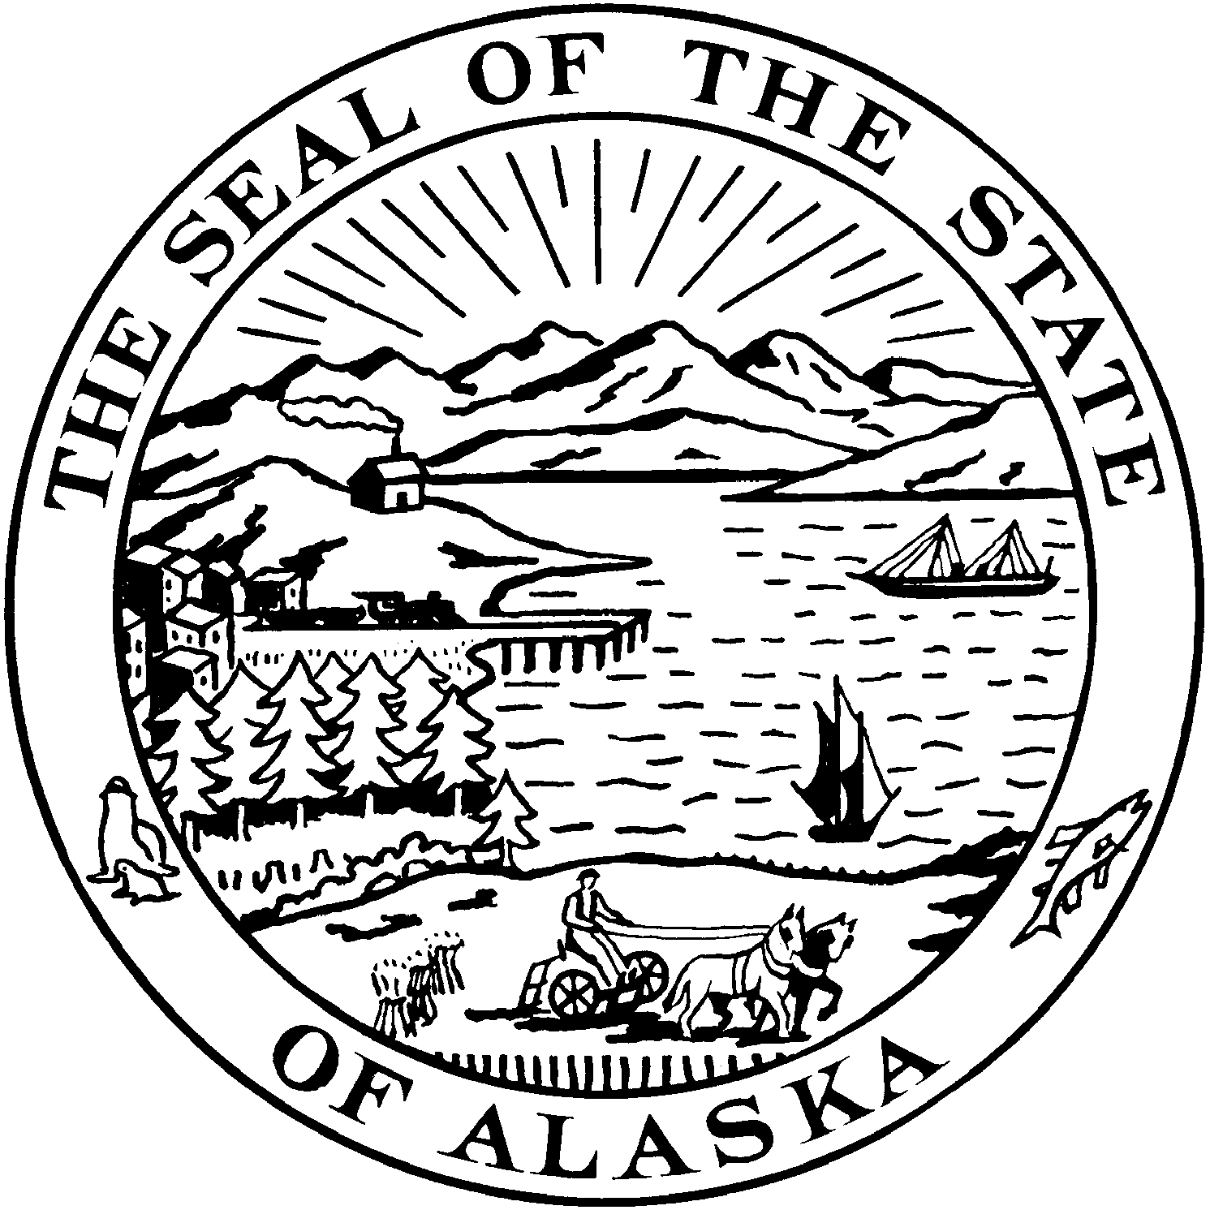
Interim:
301 Santa Claus Lane
North Pole Plaza Mall Ste. 3B
North Pole, Alaska 99705
Phone: (907) 451-2063
Fax: (907) 451-2332

Session:
State Capitol, Room 119 Juneau, Alaska 99801-1182
Phone: (907) 465-3719
Fax: (907) 465-3258

SENATOR JOHN COGHILL

SECTIONAL ANALYSIS
SSSB 49 am: “An Act relating to women’s health services and defining ‘medically necessary abortion’ for purposes of making payments under the state Medicaid program.”
Noteworthy: This bill was amended on the Senate Floor. Amended Sections 1 and 3 were passed with little to no vetting or analysis. Sections 1 and 3 were never discussed in any committee. The financial repercussions at the time of passage were unknown to the Senate. Section 2 of SSSB 49 has, in contrast, gone through extensive review in Senate Judiciary and Senate Finance.
Section 1: AS 47.07.030 is amended by adding a new subsection to read:
(g) The department of Health and Social Services shall make “family planning services”, “health screening examination”, and “related services” available to eligible persons.
Section 2: AS 47.07 is amended by adding a new section:
AS 47.07.068 shall read:
This section shall neutrally define “medically necessary abortions” for the purpose of making payments under Medicaid.
This section shall clearly distinguish between “medically necessary abortions” and “elective abortions.”
Medicaid does not fund elective procedures (such as a facelift).
Medicaid also shall not fund elective abortions.
Medicaid only funds medically necessary procedures.
Medicaid shall only fund medically necessary abortions.
The definition was crafted after giving careful consideration to existing federal foundational thresholds found in the Hyde Amendment, the language in the 2001 “Planned Parenthood Case” (State, DHSS v. Planned Parenthood, 28 P.3d 904, 915 (Alaska 2001)), and the neutral, professional recommendations of medical experts.
- The department shall not pay for abortions unless the services are medically necessary or the pregnancy was the result of rape or incest. Payment shall not be made for elective abortions.
- (1) “Abortion” shall be as defined in AS 18.16.090.
(2) “Elective abortion” means an abortion that is not medically necessary.
(3) “Medically necessary abortion” means, in a physician’s objective and reasonable professional judgment, after considering neutral medically relevant factors, that an abortion must be performed to avoid a threat of serious risk to the life or physical health of a woman from continuation of the woman’s pregnancy;
(4) “Serious risk to the life or physical health” includes, but is not limited to, a serious risk to the pregnant woman of:
(A) death; or
(B) impairment of a major bodily function because of
(i-xxii) the conditions listed.
Section 3: The uncodified law of the State of Alaska is amended by adding a new section to read:
That a new “Women’s Health Program” shall be established under Medicaid. The plan shall be consistent with Section 1.

