31st Alaska State Legislature

Rules Committee
Chairman
Judiciary Committee
Chair
State Affairs Committee
Vice-Chair
Resources Committee
Vice-Chair
Select Committee on Legislative Ethics
Legislative Council

Session Address:
State Capitol, Room 103
Juneau, AK 99801-1182
(907) 465-3719
Fax (907) 465-3258

Interim Address:
1292 Sadler Way, Suite 340
Fairbanks, AK 99701
(907) 451-2997
Fax (907) 451-3526
(877) 465-3719

www.alaskasenate.org
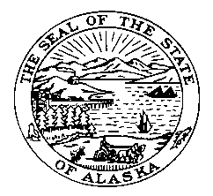

Senator John Coghill

SPONSOR STATEMENT

SJR14
“Proposing an amendment to the constitution of the state of Alaska relating to actions upon veto.”

SJR 14 lowers the threshold for overriding the governor’s veto of appropriations to two-thirds of the membership of the legislature. This sets the standard for veto overrides of appropriations in line with the existing threshold for non-appropriation vetoes and mirrors the majority of other states in the nation.

The Constitution of Alaska gives the governor more power than any other state. He appoints his cabinet, the Attorney General, Boards and Commissions, Judges and the Board of Regents and appoints two members of the redistricting board.
Few state constitutions grant as much authority to the governor as Alaska does. This is because most of the other constitutions were written with a history of tyrannical or corrupt executives in mind.

Alaska is the only state or territory in the United States that requires three-fourths of the legislature’s membership vote to override appropriation bill vetoes.

It is essential that the constitutionally granted separation of powers between legislative and executive branches be beneficially rebalanced.

